Total marks:

/60

/20%

|  |  |  |  |  |  |  |  |  |  |
| --- | --- | --- | --- | --- | --- | --- | --- | --- | --- |
| **Marking Rubrics** | | | | | | | | | |
| Group name: | | Group 1 | | |  | | | | |
| Names and ID: | | Goh Yi Cheng (Group Leader) | | | 2206335 | | | | |
|  | | Toh Yong Cheng | | | 2206765 | | | | |
|  | | Wong Jea Sen | | | 2205984 | | | | |
|  | | Hiew Yi Zhe | | | 2000318 | | | | |
|  | **Criteria** | **Poor** | **Below Average** | **Average** | | **Good** | **Excellent** | **Marks** |  |
|  | **Construct** | **0-3** | **4-6** | **7-9** | | **10-12** | **13-15** |  |  |
| **static web** | Little or no | Basic understanding | Good understanding of HTML | | Excellent understanding of | Exceptional understanding of |
| **pages** | understanding of | of HTML and CSS; | and CSS; pages are well- | | HTML and CSS; pages are | HTML and CSS; pages are |
| **(15 marks)** | HTML and CSS; | pages are mostly | structured and visually | | highly structured and visually | expertly structured and |
| **[CO1]** | pages lack structure | structured and | appealing, with some minor | | appealing, with a clear | visually stunning, with a |
|  | and design; visual | visually appealing, | improvements possible. | | understanding of design | mastery of design principles. |
|  | elements are poorly | but with some issues. |  | | principles. |  |
|  | aligned and |  |  | |  |  |
|  | unattractive. |  |  | |  |  |

|  |  |  |  |  |  |  |  |  |
| --- | --- | --- | --- | --- | --- | --- | --- | --- |
|  | **Build dynamic web pages using event- driven client- side scripts (15 marks) [CO2]** | **0-3**  Little or no understanding of client-side scripting languages; pages are static and lack interactivity. | **4-6**  Basic understanding of client-side scripting languages; pages have some interactivity and respond to user input, but with some issues. | **7-9**  Good understanding of client- side scripting languages; pages are highly interactive and respond well to user input, with minor improvements possible. | **10-12**  Excellent understanding of client-side scripting languages; pages are very interactive and highly responsive to user input, with a clear understanding of event-driven programming techniques. | **13-15**  Exceptional understanding of client-side scripting languages; pages are expertly interactive and highly responsive to user input, with a mastery of event-driven programming techniques. |  |  |
|  | **Develop server-side and database- driven web applications (15 marks) [CO3]** | **0-3**  Little or no understanding of server-side scripting languages and databases; web applications are non- functional, insecure, and not scalable. | **4-6**  Basic understanding of server-side scripting languages and databases; web applications are functional, but with some security and scalability issues. | **7-9**  Good understanding of server- side scripting languages and databases; web applications are functional, secure, and scalable, with some minor improvements possible. | **10-12**  Excellent understanding of server-side scripting languages and databases; web applications are highly functional, secure, and scalable, with a clear understanding of validation and error-handling mechanisms. | **13-15**  Exceptional understanding of server-side scripting languages and databases; web applications are expertly functional, secure, and scalable, with a mastery of validation and error-handling mechanisms. |  |  |

|  |  |  |  |  |  |  |  |  |
| --- | --- | --- | --- | --- | --- | --- | --- | --- |
|  | **Report**  **(10 marks)** | **0-2**  Poor documentation and presentation, difficult to understand. | **3-4**  Basic documentation, lacking clarity or organization. | **5-6**  Good documentation and presentation, with some areas needing improvement. | **7-8**  Well-documented and clear presentation, easy to follow with minor improvements possible. | **9-10**  Exceptionally well- documented and professionally presented, clear and highly informative. |  |  |
|  | **Peer Evaluation (5 marks)** | **1**  No contribution. | **2**  Contributions are minimal or not relevant to project goals. | **3**  Contributions are somewhat relevant but could be improved. | **4**  Contributions are generally helpful and relevant to project goals. | **5**  Contributions significantly enhance project goals and outcomes. |  |  |

Table of Contents

1.0 Introduction 5

2.0 Full explanation 6

**2.1 Database – `database.sql`** 6

**2.1.1 Database connection - `database.php`** 6

**2.2 Home page** 9

**2.3 User Authentication** 13

**2.3.1 Login and Sign Up** 13

**2.3.2 Client’s Side and Server’s side Validation** 14

**2.3.3 Form and Data Handling** 19

**2.4 Product Listing** 21

**2.4.1 Load product from database** 21

**2.4.2 Product Filters and Sort** 25

**2.5 Product Details** 27

**2.5.1 Client’s Side and Server’s side Validation** 29

**2.6 Cart** 33

**2.6.1 Add to cart - `add_to_cart.php`** 34

**2.6.2 Update cart - `update_cart.php`** 35

**2.7 Check out** 36

**2.7.1 Check out section** 36

**2.7.2 Addresse and Payment Details** 38

**2.7.3 Update stock in database** 40

**2.8 Contact us** 41

**2.9 Profile maintenance** 45

**2.9.1 Personal Info** 45

**2.9.2 Edit Profile** 45

**2.9.3 Order History** 48

**2.9.4 Review Product** 49

**2.9.4 View Statistics** 51

**2.10 Responsive Design** 53

3.0 Conclusion 56

Extra: Future Enhancement 56

4.0 Workload Summary 57

5.0 References SUB. (n.d.). *Home*. https://www.sub.com.my/ 58

# **1.0 Introduction**

Our project **TUB Concept Store** is a type of web-based e-commerce application that consists of a modern, convenient and a user-friendly interface. This project was developed using HTML, CSS, JavaScript, PHP and SQL which integrate front-end and back-end development to create a dynamic and responsive platform for showcasing and selling concept-based products. For this project, we implemented object-oriented concept by creating classes that handle interactions with the backend and the database.

The main goal of the TUB Concept Store is to assist users and/or customers with a user-friendly interface where they can scroll and take a clear glance on our products, which consists of numerous detailed apparel design, with further descriptions based on the products style like colour and size as well as manage their online shopping carts in a very efficient way.

In this system, essential functionalities are developed such as authentication process for users (login and logout) that enabling secure access for registered users. Besides, users can browse the products, filter products based on their preferences and view product details. Moreover, users can add products to cart, make a payment and view their orders history as well as overall transaction statistics annually. Additionally, the application allows users to manage their personal profiles, leave product reviews. In addition, database management was implemented to handle user data, product details, order details and so forth.

This project not only serves as a practical demonstration of the technical skills acquired during the course but also highlights the importance of user-centred design and effective system architecture in web application development. The product details used in this website, the colour scheme and layout were inspired by the design of a commercial website (SUB, n.d.).

# **2.0 Full explanation**

## **2.1 Database – `database.sql`**

There are a total of 7 tables in the database, which are the user table, product table, images of product table, size and stock of product table, cart item table, order table, and ordered item table.

# User Table

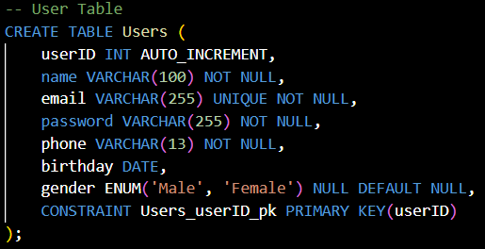

At this sign-up page, the user will key in their name, email, password, and phone number. Here are some attributes of the variables:

* Every time a new user is added, the ID will increase automatically, giving each user a unique ID.
* One email can only be used by one user.

### **2.1.1 Database connection - `database.php`**

# Classes to make connections with database

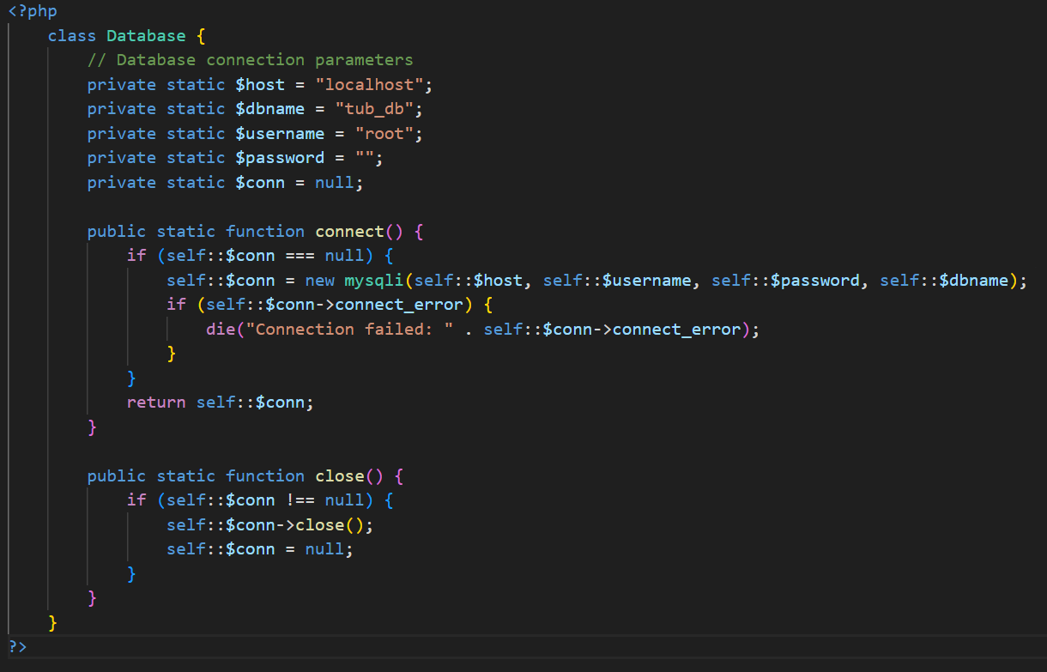

In this project we are using object-oriented approach to interact with backends. The Database classes acted as a medium to make connections with database.   
# classes/user.php

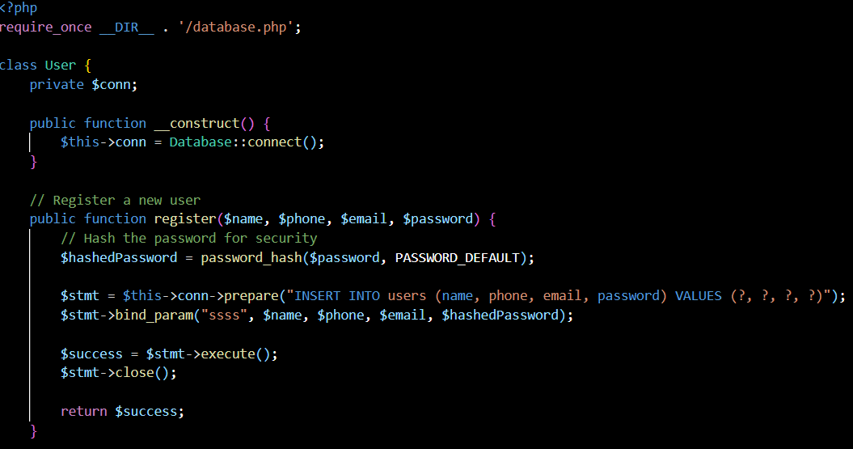

For example, the User class uses the Database class to establish a connection by calling Database::connect() in its constructor. This allows the User class to perform database operations, like registering a user, without handling connection details directly and repeatedly which make the code maintainable.

#ERD Diagram

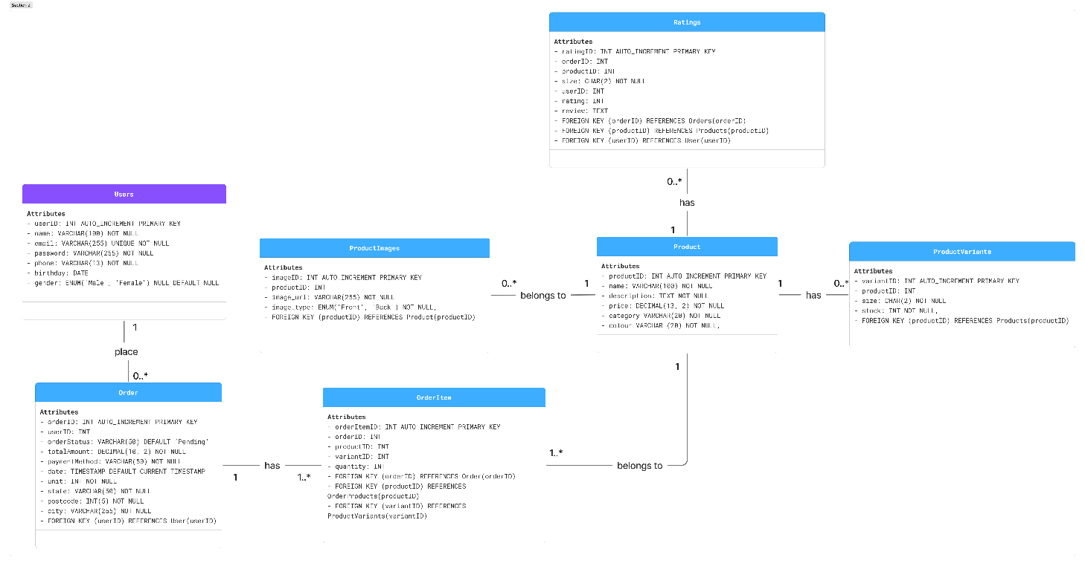

# Relationship

One user can place zero or many orders

One order can only be made by a user

One order must have at least 1 order item or many order items.

The specific order item can only be from one order

A product can have zero or many images (front, back, etc.)

A product image only belongs to one product

A product can have zero or many products ratings

A product rating only belongs to one product

A product can have zero or many products variants

A product variant only belongs to one product

A product can have zero or many Order Items

An Order Item only belongs to one product

## **2.2 Home page**

# Home page – `index.php`

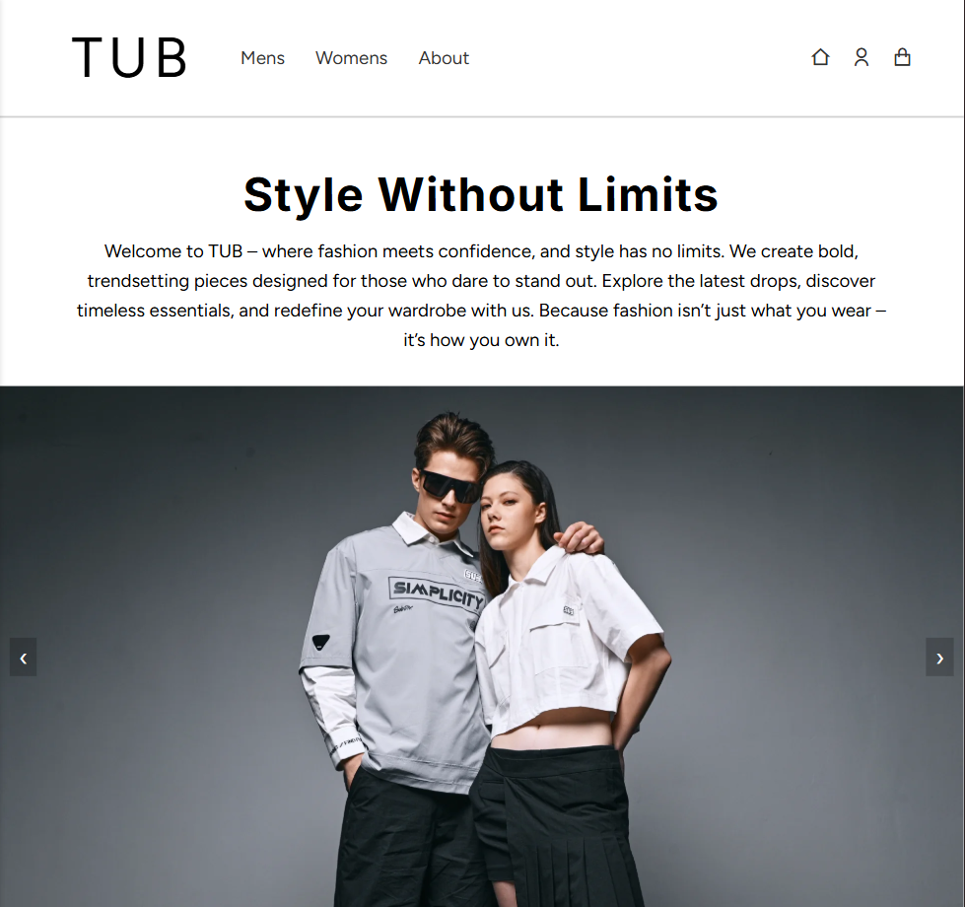

According to our homepage, the website titled “TUB” features a wide range of apparel designs with various models showcasing different outfit styles. With the family-friendly motto “Style Without Limits”, TUB aims to inspire confidence through fashion.

# New Arrivals Section

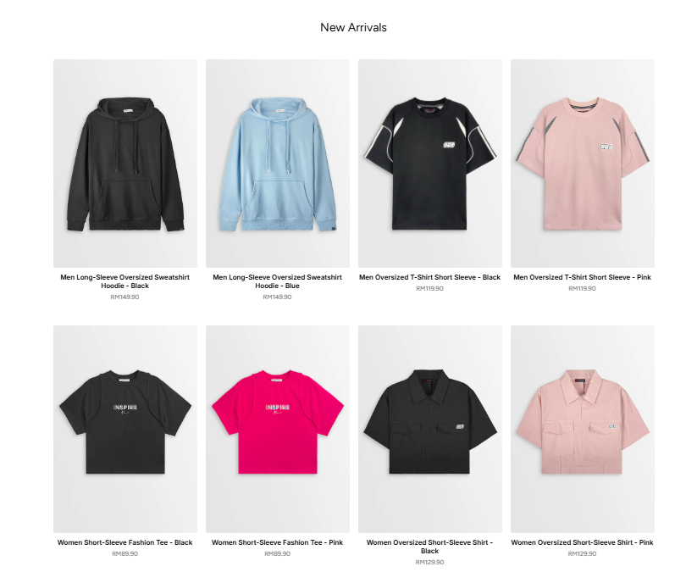

Allows users to view new arrivals product. Only 8 products are fetched from database for display purposes.

# Shop by category section

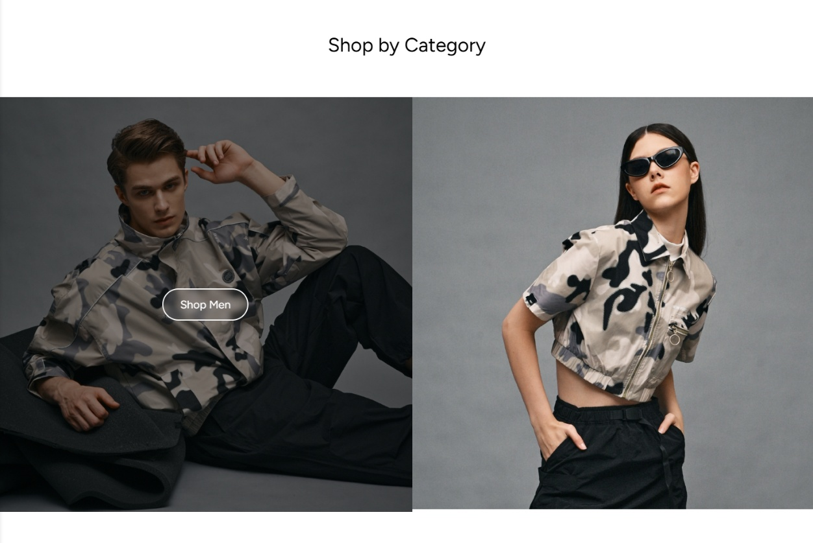

Allows users to choose the type of outfits they want to view based on gender

# Reason for choosing our brand section along with footer

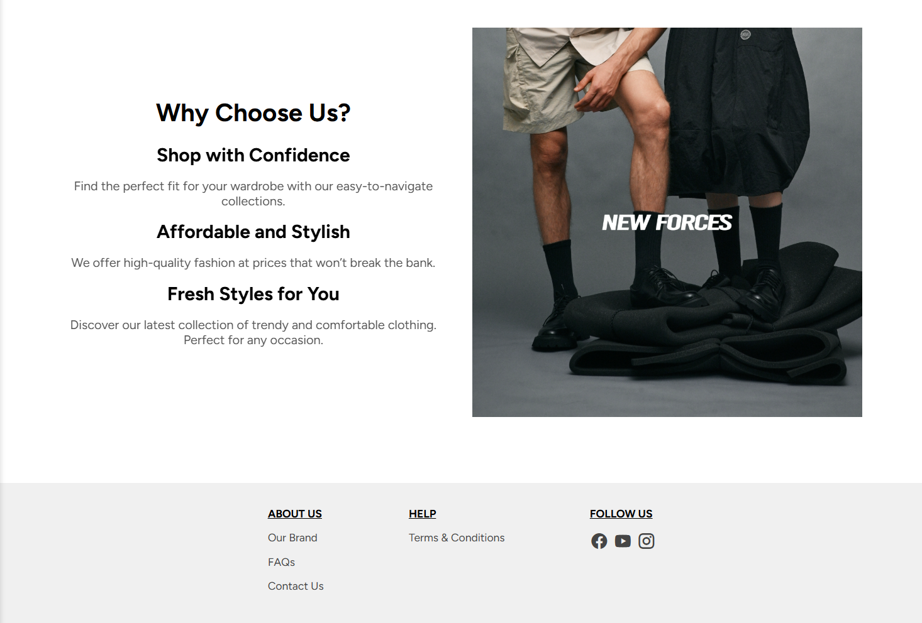

# Navigation bar



Based on the navigation bar, each menu item redirects user to different page if it is clicked:

1. **TUB logo** and **Home icon**: Returns the user to the homepage.
2. **Mens**: Navigate to the product listings page that contain men’s product only
3. **Womens**: Navigate to the product listings page that contain women’s product only
4. **About**: A dropdown menu that includes

* Our Story: Redirects users to a page with the story of our brand
* Contact Us: A page where users can get in touch with customer support for inquiries by filling the form and view our store’s addresses.

1. **User icon**: Redirect to the login/profile management page.
2. **Cart icon**: The shopping cart where they can review selected items before checkout.

# Footer

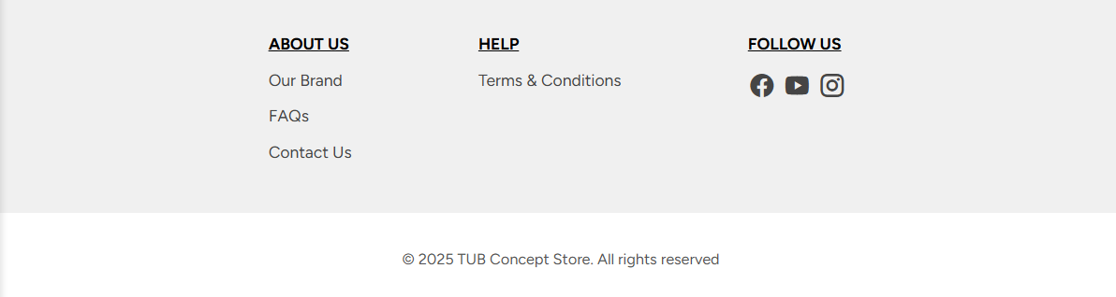

Based on the footer, the menu item also redirects user to different page:

1. **Our Brand**: Redirects users to a page with the story of our brand
2. **FAQs**: Pages that display frequently asked question by customers
3. **Contact Us**: A page where users can get in touch with customer support for inquiries by filling the form and view our store’s addresses.
4. **Terms & Conditions**: A page that displays terms and conditions of our store

## **2.3 User Authentication**

The user authentication process starts with the user accessing the login or registration page and entering their credentials. When user filled the crendetials, Front-end validation is to ensure required fields are filled correctly before sending the data to the server. Next, backend served to verified user’s credentials. If login successfully, a session is created to store user information.

### **2.3.1 Login and Sign Up**

After clicking the User icon, user will be navigates to this page. For non-login user, an message will be prompted

# Pop-up message for user who haven’t loggged-in

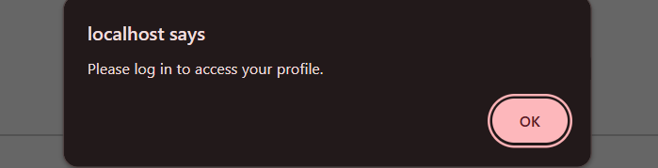

# Login Page – `user/login.php`

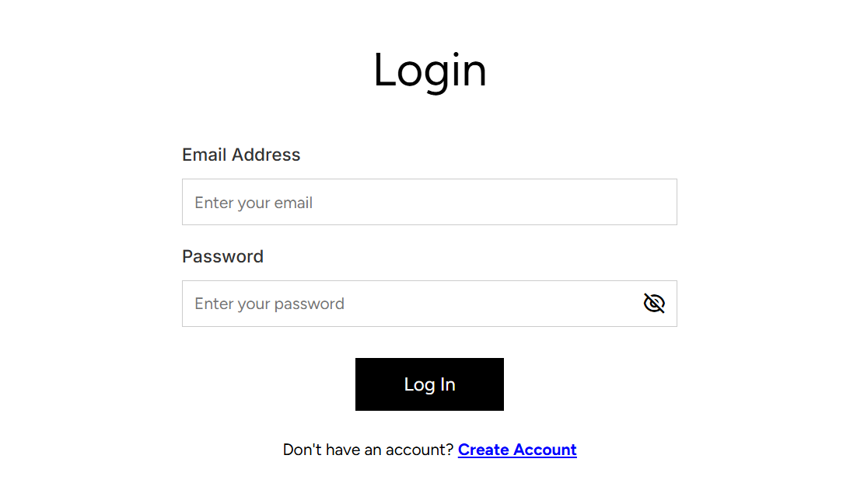

Allow user to login using their personal account along with password. If user not having an account, user can register a new account by clicking the “Create Account” link.

# Sign Up page – `user/signUp.php`

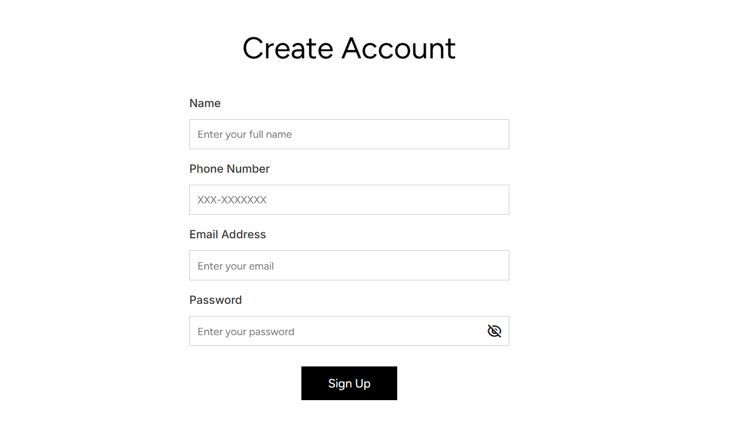

### **2.3.2 Client’s Side and Server’s side Validation**

Before submitting the data to backend, we will perform a front-end validation to ensure that valid input is collected so that it is easier for server side to process. The server’s side validation is served as a second “security wall” to ensure that correct data are collected and will be stored to database.

# Empty input

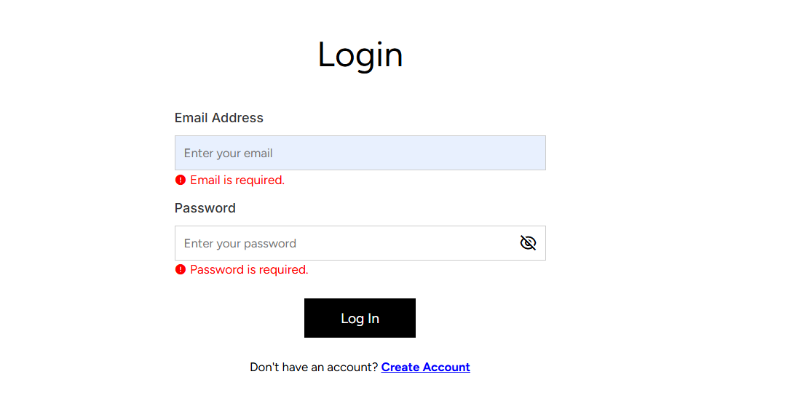

A validation message is prompted if any absence of entering email or password.

# Validation of Email Format

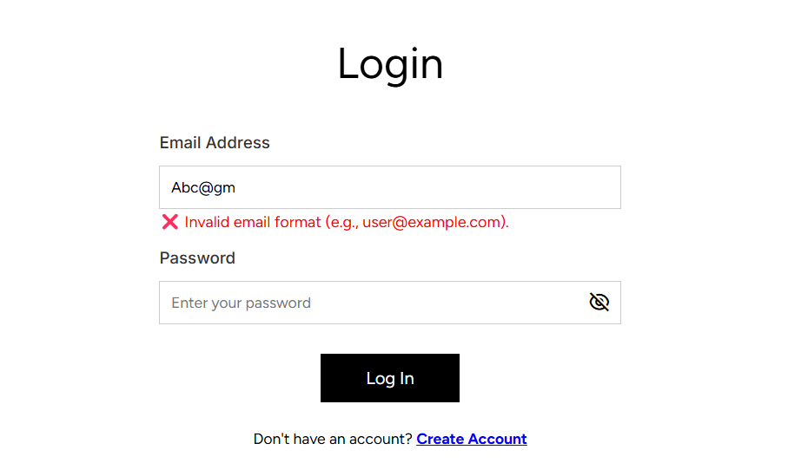



The email address’s format validation is performed on client’s side.

# Validation of email for client’s side

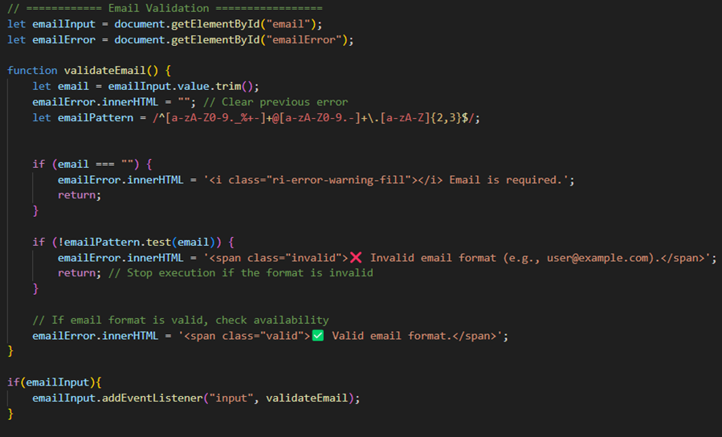

The error message is prompted on real time when user key in the value which enhanced the user friendliness.

# Non-existent email in login section – Server side

For this validation, it is processed using back-end validation since we need to check whether the email provided are registered during the login process.

# Function to check existence of an email (written in `classes/user.php`)

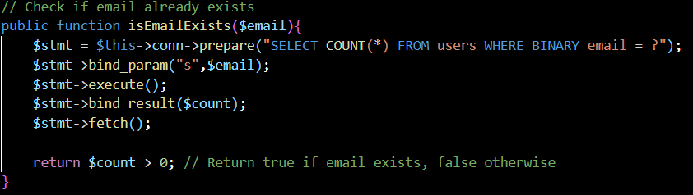

This function is called in the `user/login.php` after the login form is submitted. We going to mentioned it later.

# Incorrect password



Same as the previous one, this validation also validated through backend.

# Function to login user into the system

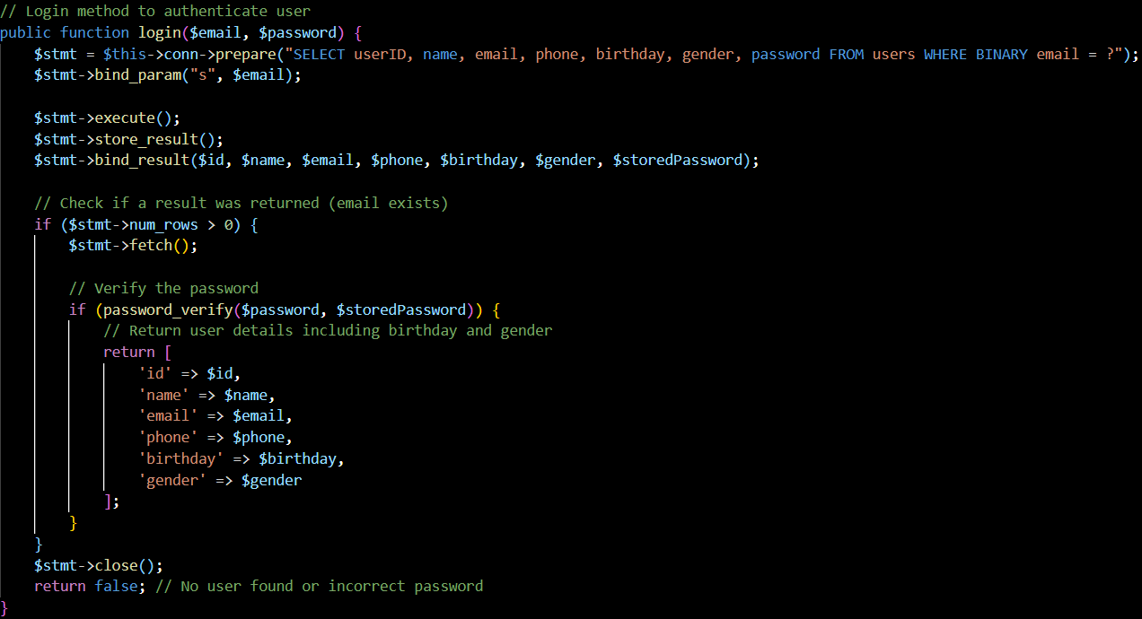

When the data sends to backend, the function above is executed and try to fetch the user details with credentials provided. It will loop through every record stored in database to found a matched email and password. If found it return true else, it returns false.

# Validation for creating account section – `user/signUp.php`

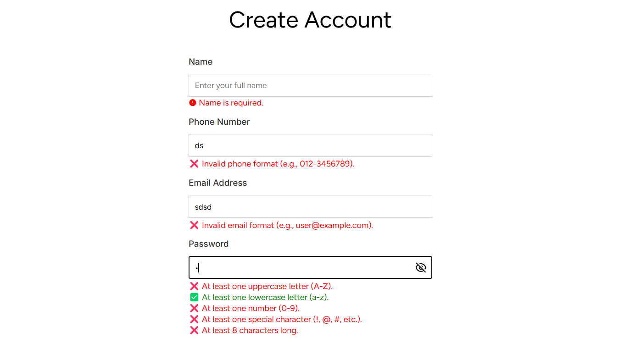

Likewise, the create account page also implemented client’s side validation that we mentioned just now. The only difference is we performed on different fields like phone number and password. For the password field, validation rules included a minimum 8 characters requirement, the use of at least one uppercase letter, lowercase letter, one number, and one special character to enhance security.

# Client’s side function to validate password

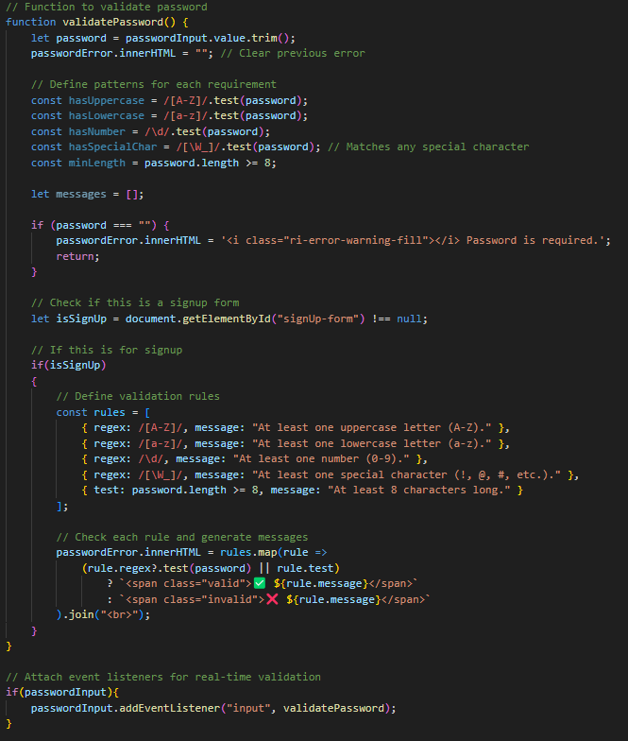

# Register for an existing email



For this backend validation, we use back the same function in the login page to validate which is login ($email, $password)

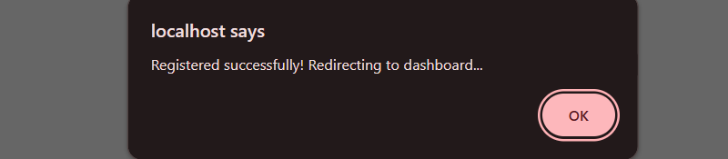

A message is prompted to user if they create a new account successfully. In contrast, user who logs in successfully into the system will be redirected to home page.

# Registered user information in database

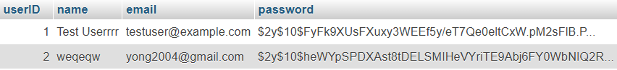

The password stored inside in database is hashed to ensure more secure.

### **2.3.3 Form and Data Handling**

Both login form and sign-up form are aimed to collect user’s information like email address and password. The form’s data is passed to backend using “POST” method for security purposes since sensitive data like password are collected. Although we had done the front-end validation on previous stage, a backend validation is included as a second ‘security wall’ since someone can easily bypass the front-end validation. Since the login form and sign-up form are almost the same, we only showing login section below to present our thoughts.

# Login Form

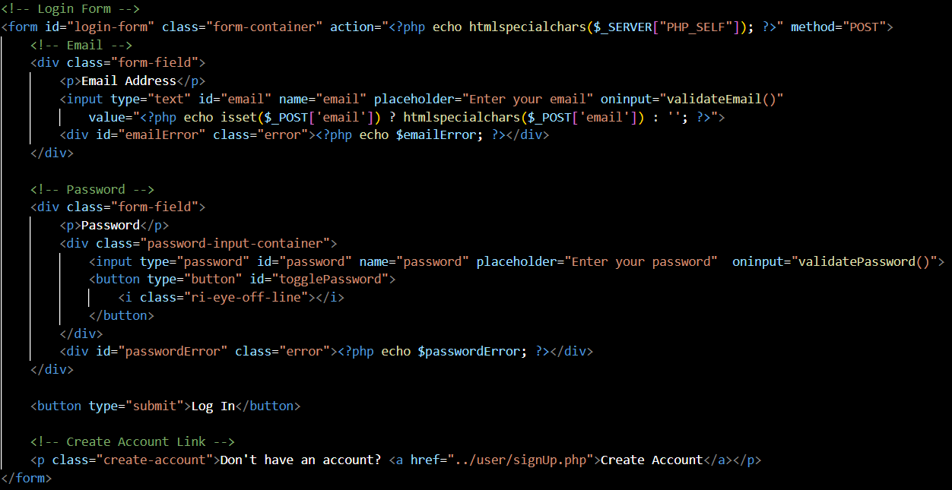

Collect user information like email address and password.

# Example of backend validation

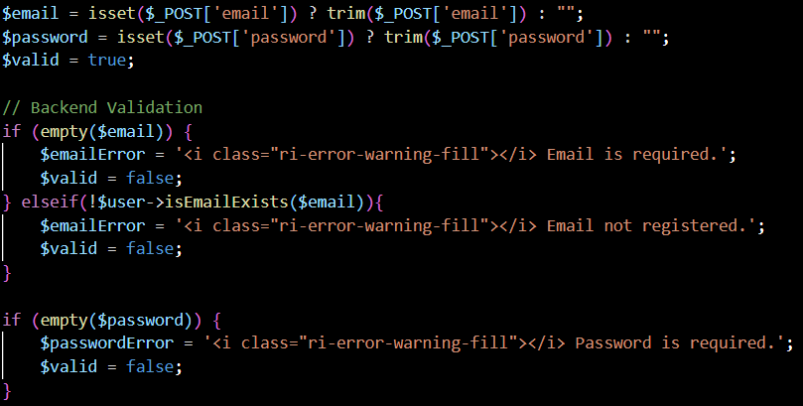

After data passes through the frontend, it's crucial to validate it again on the backend

# Example of logging user in by calling the function in `classes/user.php`

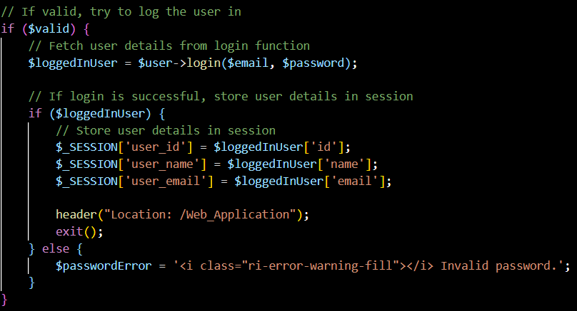

This what we mentioned just now by calling the function in user’s classes, $user->login($email, $password)where $user is the instance of user’s classes to perform user authentication process. After a successful login, user details are stored in session variables. This allowing the system to verify whether the user is currently logged in which is essential for restricting certain functionalities, such as purchasing a product, to authenticated users only.

## **2.4 Product Listing**

### **2.4.1 Load product from database**

To display product to user, we must load the product from database first. Here is the flow of loading the product data from the database:

1. First, the **`js/load_products.js`** is included in **`products_listing.php`**

2. In the **`load_products.js`**, it uses the **`get_products.php`** if the user is in the products listing page (which is in the same folder), else the directory will be **`product/get_products.php`.** Then, a GET request was sent to the endpoint

3. If the server responds successfully, .json() converts the response into a JavaScript object which will be an array of products. If there's any error, it logs the error and returns an empty array.

4. After fetching the product into JSON form, the product is then fetched in the <div></div> container to be displayed in **`products_listing.php`.**

# Fetching products (`js/load_product.js`)

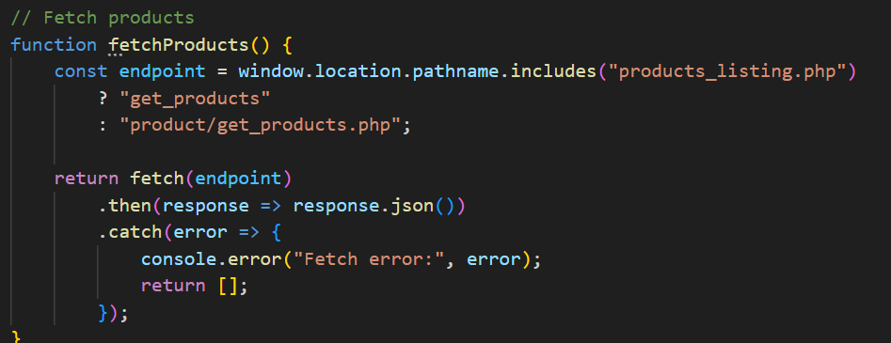

# The product’s images and variants are fetched from the database.

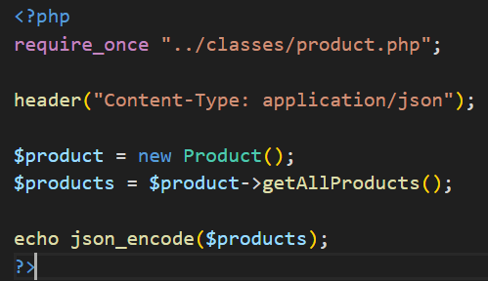

* The code above is the **`get_products.php`**, which is called by the fetchProducts() function above.
* The code creates a new instance of the product class, then it calls $product->getAllProducts() to retrieve all products and their info, such as image and variant from the database and the product are encoded into JSON.

# SQL statement to fetch the product

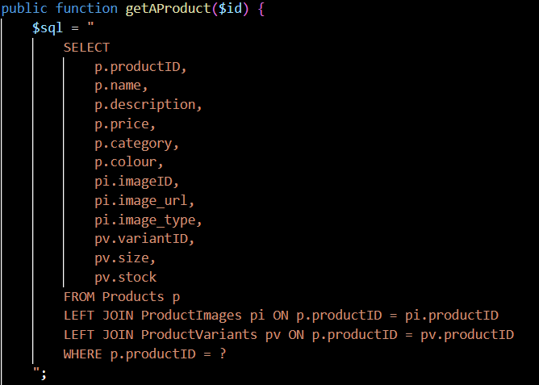# Fetched product in JSON format

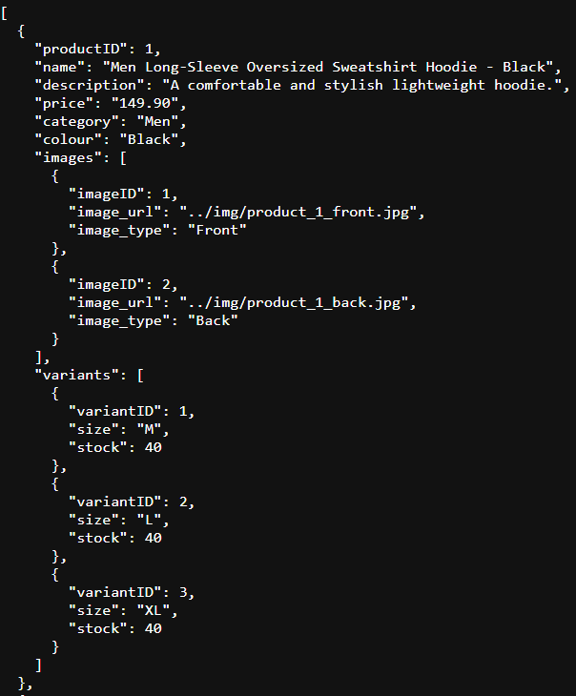

# Fetch JSON form’s product into div container

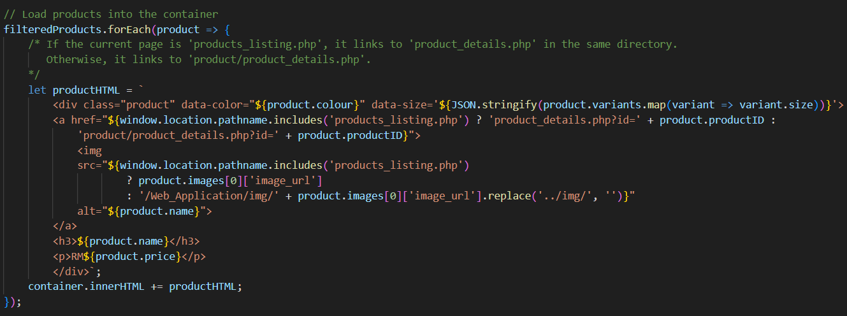

Recalled that for index.php, we are having 8 new arrivals products, those products also fetched using this function. This snippet dynamically generates and inserts HTML product cards into the webpage using JavaScript.

The forEach loop goes through a list of filtered products and creates HTML blocks with key product details like name, image, price, color, and size.

* data-color and data-size: These attributes are added to enable filtering by color and size later
* Dynamic Links: The href changes depending on the current page’s path to correctly link to the product details
* Image URL: Adjusted to fit the current file path structure

# Product listing page (`product/products_listing.php`)

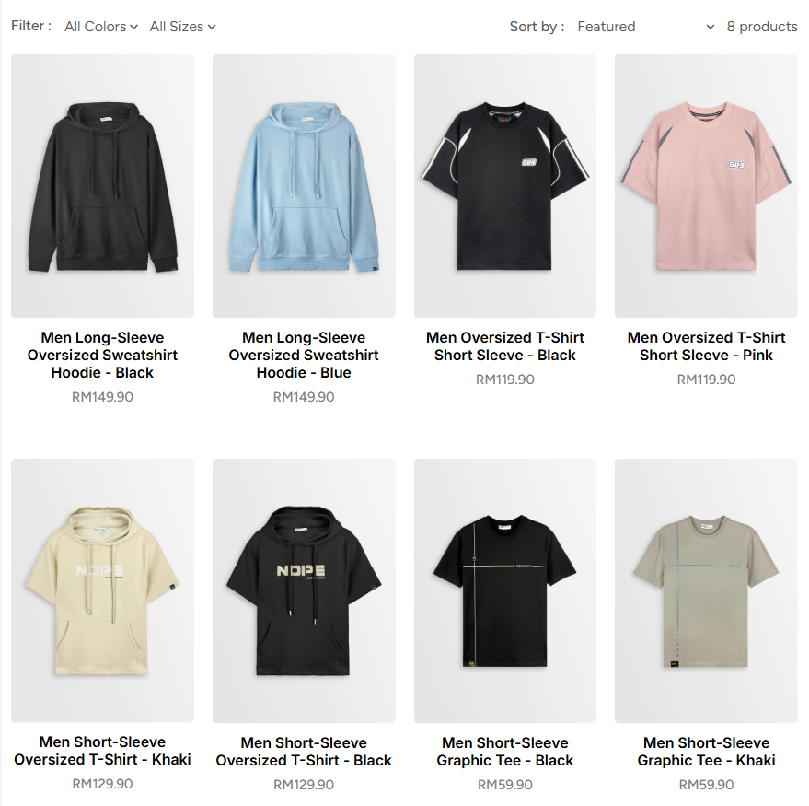

From the section above, maybe you are curious about why we are fetching product data as JSON and then rendering it with JavaScript, instead of directly loading it from the backend into HTML?  
Here’s the reason:

1. This approach allows the client-side script to efficiently handle filtering, sorting, and responsive updates without requiring a full page reload.
2. It improves user experience, especially when dealing with dynamic elements like colour and size filters, or when updating product listings based on user selections

### **2.4.2 Product Filters and Sort**

When viewing the product, user can filter and sort the product based on colour, size and features like name in ascending, descending order, price from low to high as well as from high to low. The colours and size filters are loaded dynamically based on the available product data instead of hardcoded. This keeps the filter accurate and up to date.

# Colours and size dropdown menu

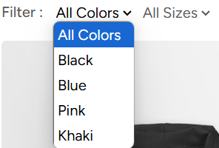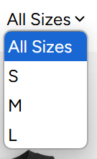

The colour filter lets users choose their preferred colour

# Featured dropdown menu

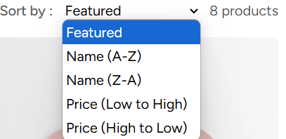

Allows people to sort the products based on name (ascending or descending) or price (low to high or high to low).

# Sort product

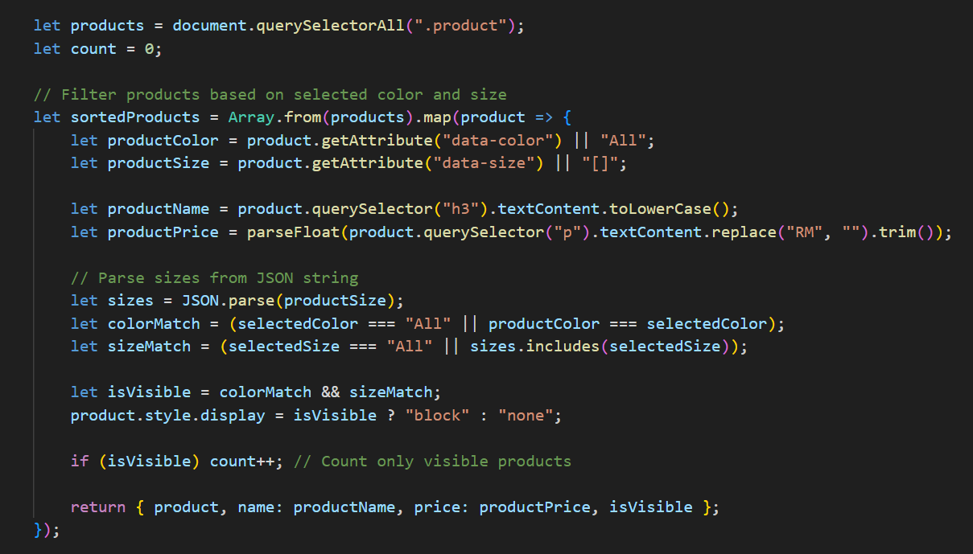

# Apply Filter

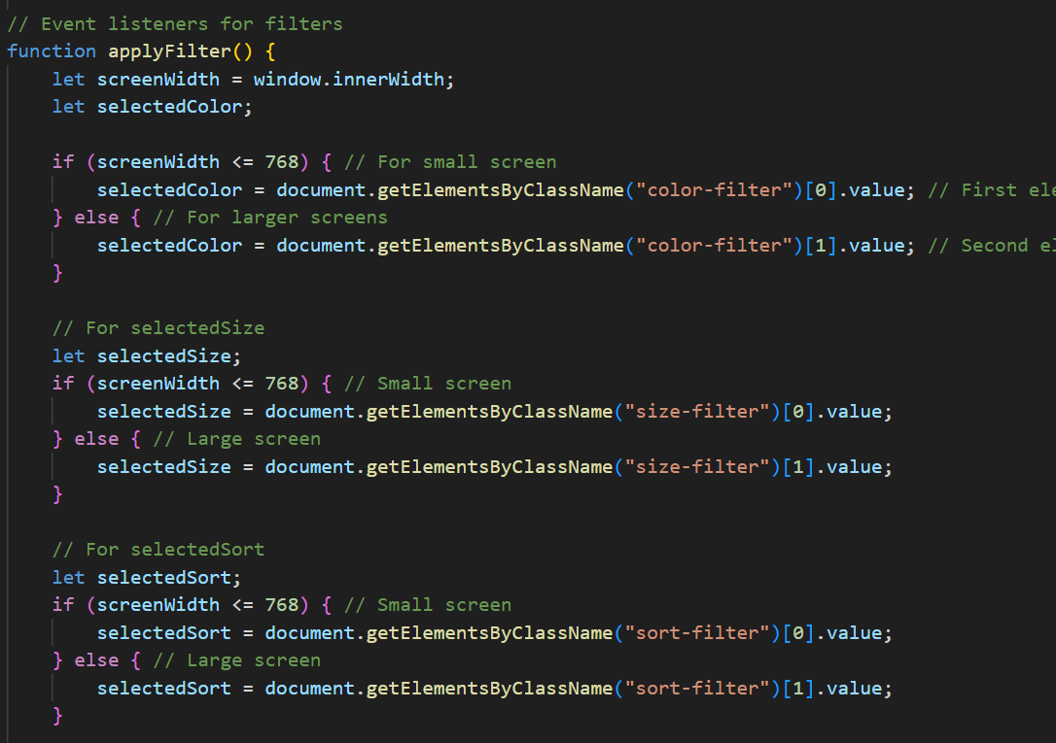

## **2.5 Product Details**

User can browse the product details by clicking any product in the product listing. Information like availability of size, colour, product’s description and user reviews (if any) are displayed. User are allowed to select their favourite size and number of items as well as add the item to cart or direct checkout. Noticed that only logged in user are allowed to use add to cart and checkout functionality.

# Check login status

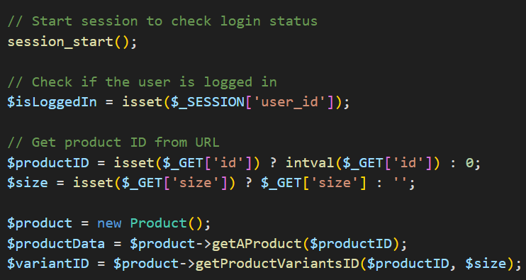

We check the login status of the user and retrieve the specific product details by product ID and size from the URL. VariantID to the same product comes in different sizes.

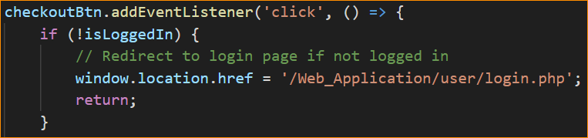

If the user hasn’t logged in, after clicking on the ‘add to cart’ or ‘checkout’ button, they will be directed to the login/sign-in page

# Product Details - `product/product_details.php`

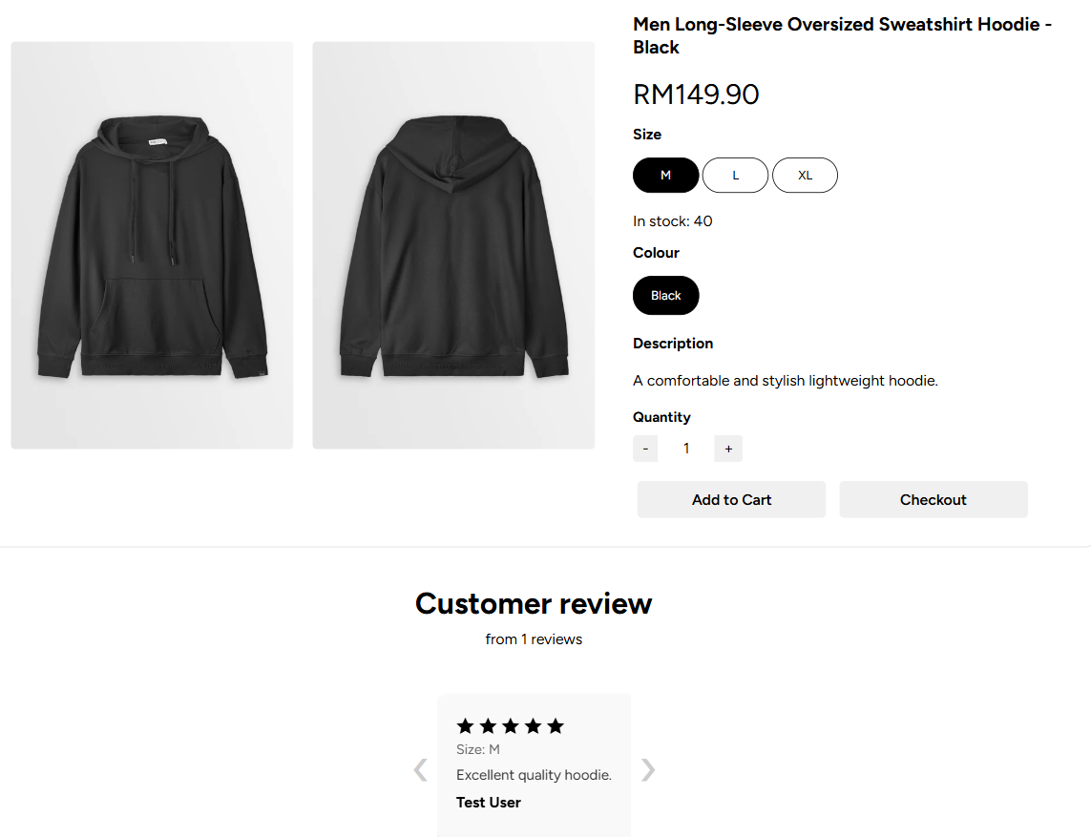

# Situation that without review



### **2.5.1 Client’s Side and Server’s side Validation**

In this section, we ensure that the product quantity entered by the user is valid both on the client side (browser) and server side (backend).

Client-side validation provides immediate feedback to users, preventing invalid input such as negative numbers, non-numeric values, or quantities exceeding available stock.

Server-side validation is crucial for security and data integrity, as client-side checks can be bypassed. It verifies that the submitted quantity is valid, available in inventory, and within business logic constraints before processing the order.

# The data is send to add_to_cart.php

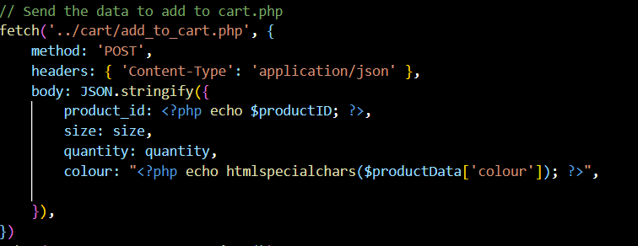

When a product is added to cart, the information like product details, size and quantity are send to `add_to_cart.php` using POST method. In `add_to_cart.php`, it will create a session variable, namely cart which will be storing these information.

# Trying to fetch information from session variables

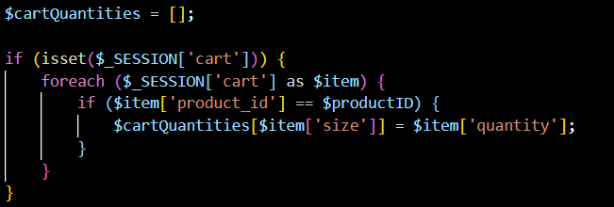

This line of code retrive information from session variables, $_SESSION[‘cart’]. After having the information, we can used these information to perform validation.

# Adding item to cart

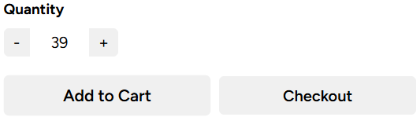  
Add the product to cart for size M

# Pop up message

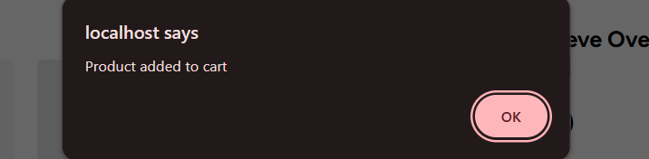

A pop-up message is shown to indicate product successfully added to cart

# Trying to input quantity that out of range

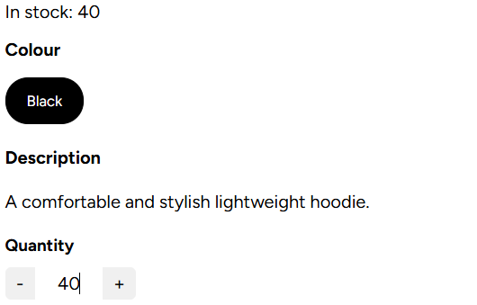

Since the maximum number of stocks for size M is 40, if we trying to type 71, which exceeds the maximum number of stocks, then the system will automatically change it to the maximum of stock available, which is 40.

# Example of code

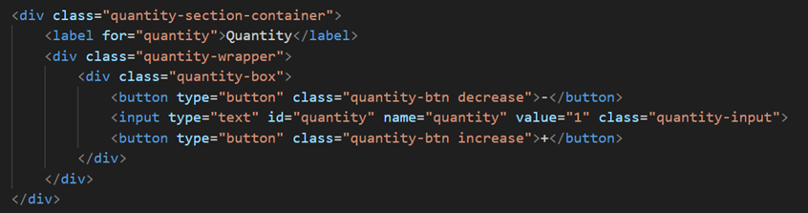

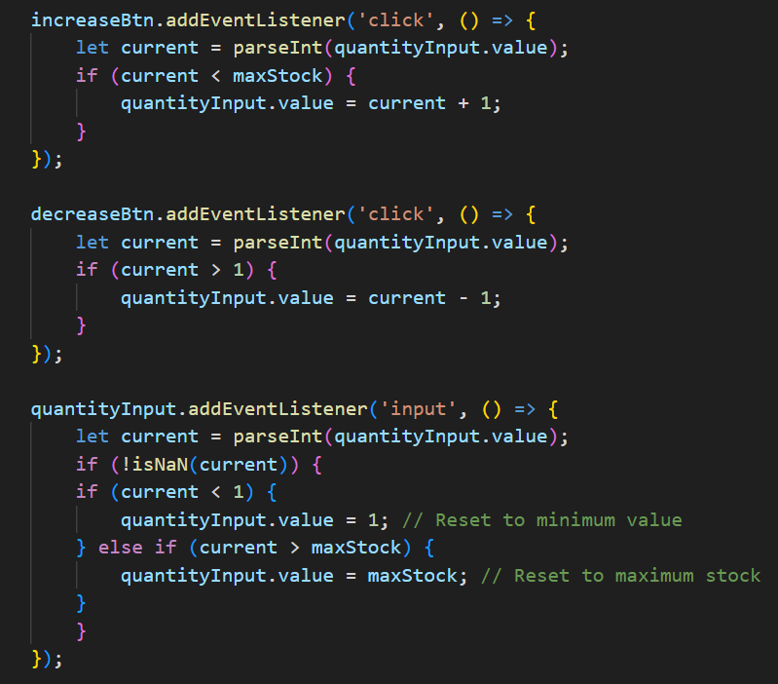

# Cart quantity validation

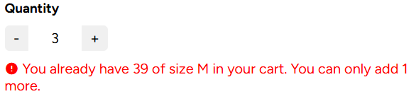

Previously we already added 39 of size M product to cart, if we trying to add more than 1 product, the error message is displayed since it exceeds the maximum of quantity we can added.



Suppose that we added the maximum of quantity to cart, if we try to add extra quantity, the error message will display.

# Validation for quantity

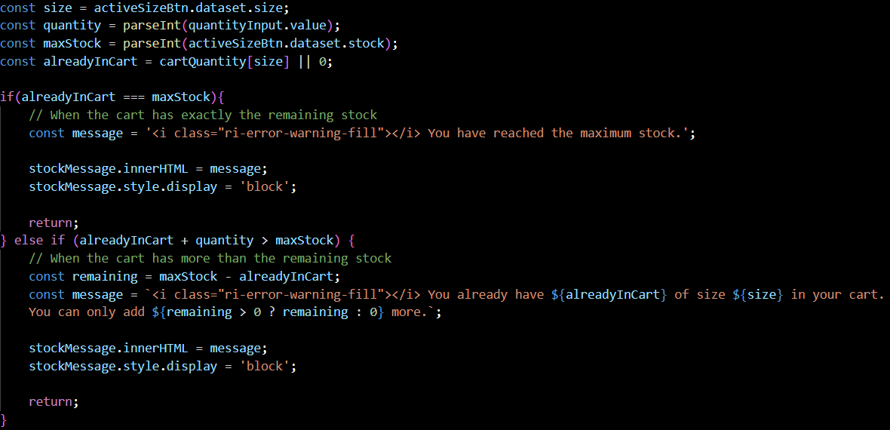

# When product is running out

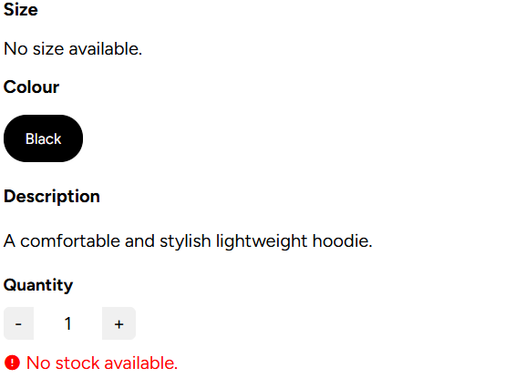

An error message is shown if user try to add product to cart or check out given that no stock available.

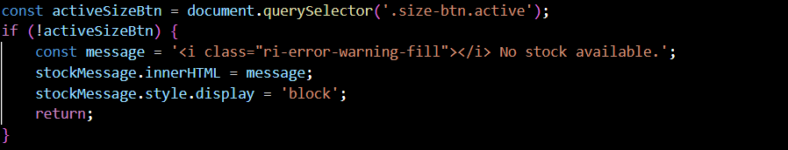

Since users are not allowed to select size when all different size for a product is running out. So, by default, the size button is not active. Hence, we can determine that no more stock available.

## **2.6 Cart**

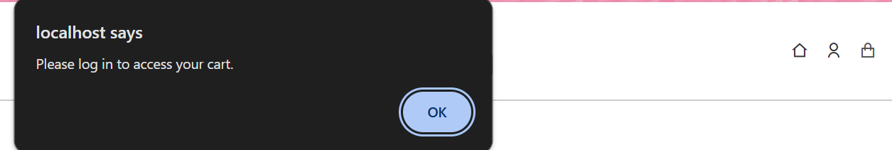

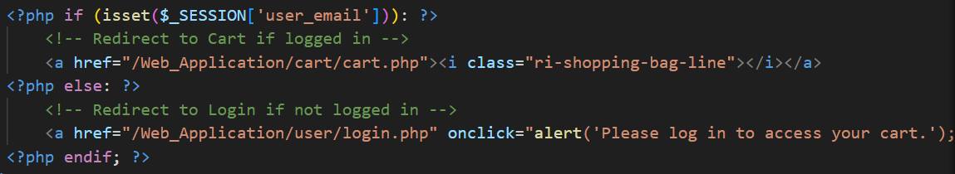

The cart icon is at the top right of the header section, where the back-end validation is applied (in **`header.php`**) to make sure the user is logged in before they can access their cart. After the alert message, the user will be directed to the login page.

# Cart details - `cart.php`

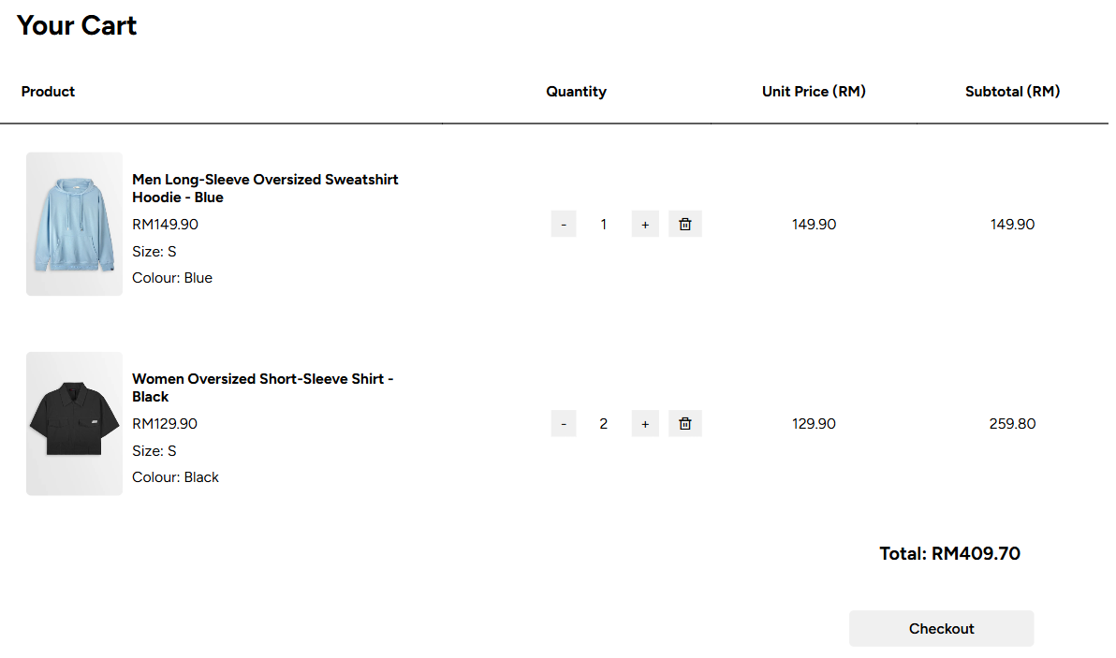

### **2.6.1 Add to cart - `add_to_cart.php`**

In previous section, we mentioned that the data is send to **`add_to_cart.php`** using POST method and a session variable, $_SESSION[‘cart’] is created. # Details of code

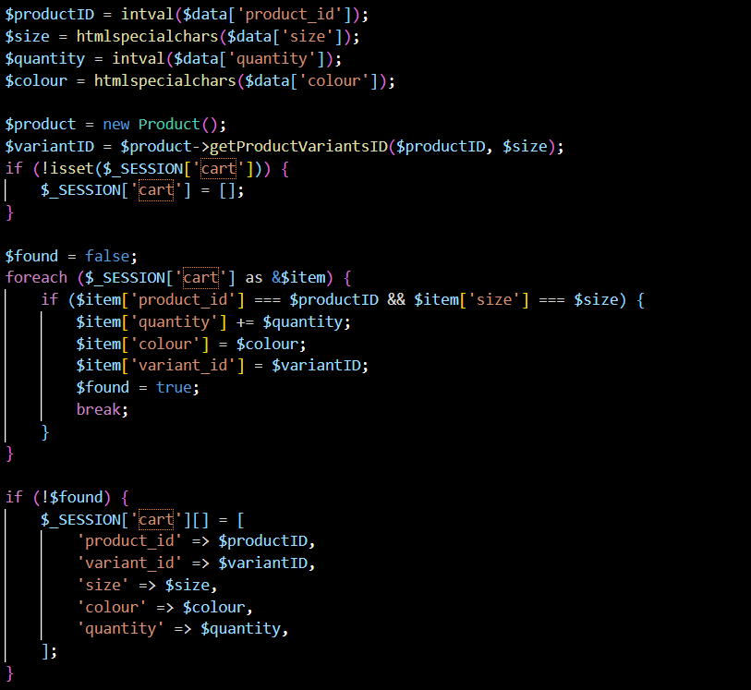

If there is no cart session variable created, a new cart will be generated to store the information. However, if the cart already exists, the details of the existing cart will be updated. For example, on the product details page, users can add products to the cart, and if they add the same product with a different quantity, the cart quantity corresponding to the product will be updated accordingly.

### **2.6.2 Update cart - `update_cart.php`**

After user adding the product to cart, user can modify the cart’s quantity in `cart.php` instead of going back to product details section and add it. Overhere, user can still modify or change the quantity of their items, or simply just remove them, where the subtotal price will change accordingly.

# Details of code

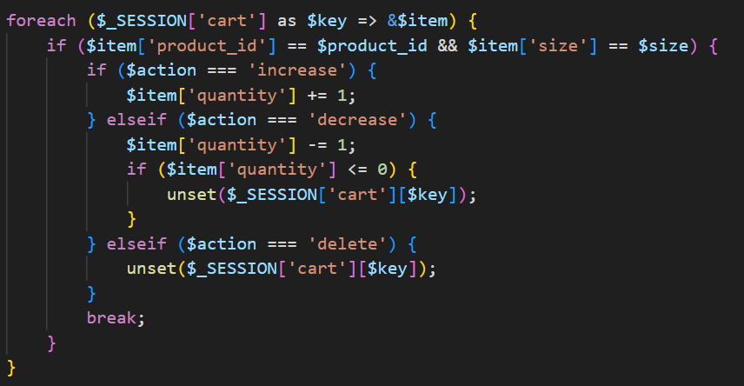

# Demonstration

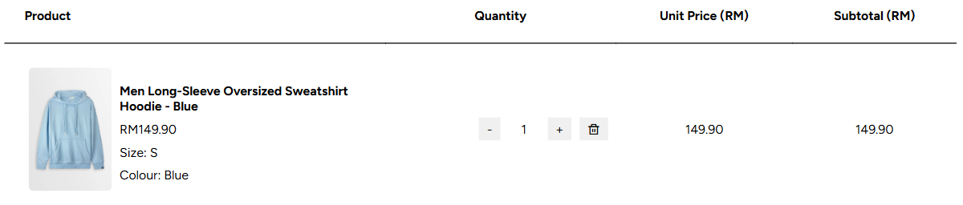

# Add 2 more product

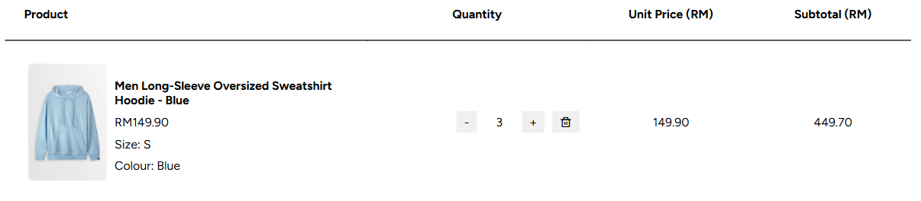

## **2.7 Check out**

### **2.7.1 Check out section**

The user will be directed to the payment page after clicking checkout in the cart. User can choose to direct check out for one product in the product details page or check out for at least one product in cart page.

# Direct check out for single product - `product_details.php`

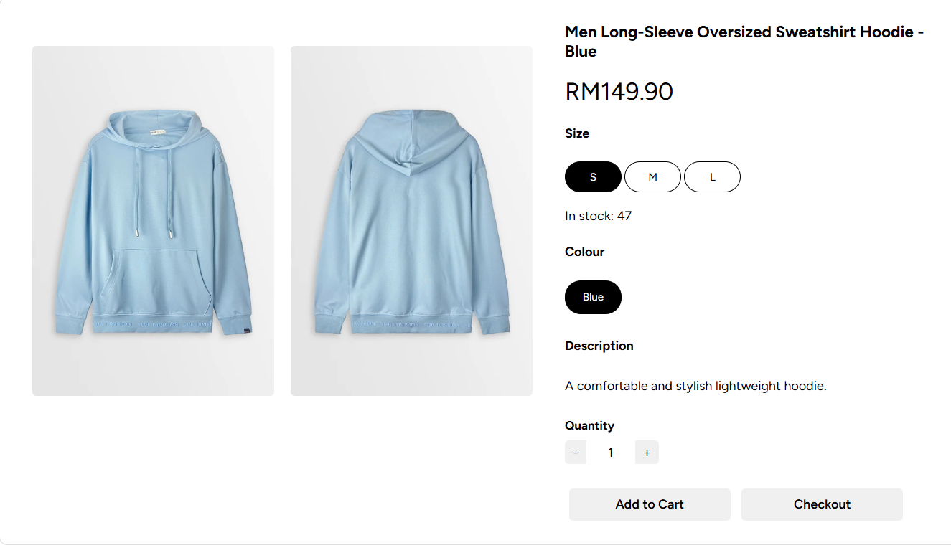

The user may check out at the product details page without adding it to the cart, but they will be buying that one single product, without accessing the cart. They will be directed to the **`payment.php`** page instead of **`cart_payment.php`** (they have the same functions)

# If user try to add extra product given that maximum product reach

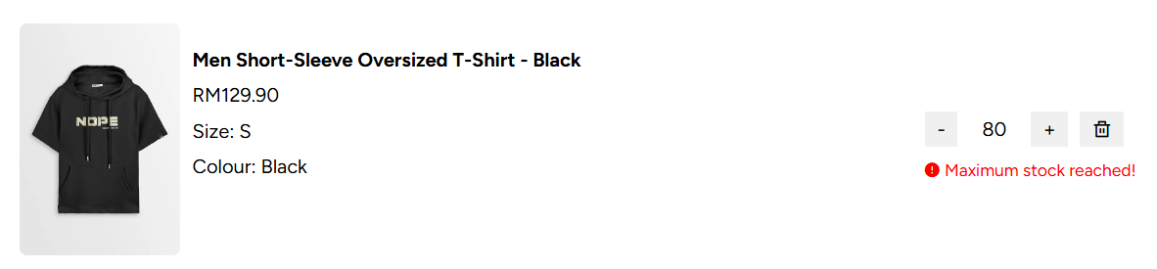

# Check out for at least one product - `cart.php`

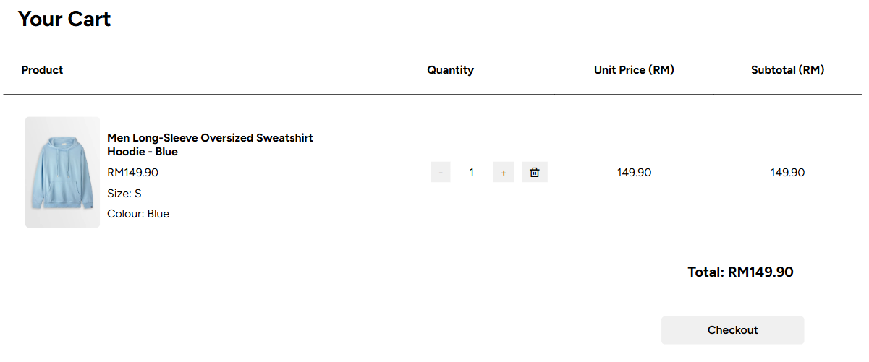

# The checkout button at `cart.php`

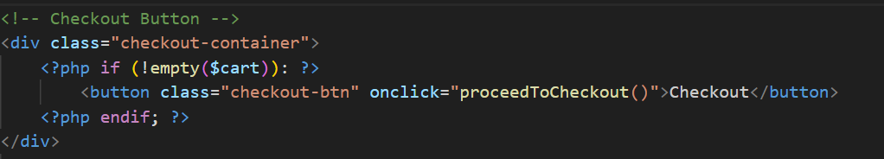

# Proceed to `cart_payment.php` after clicking check out button

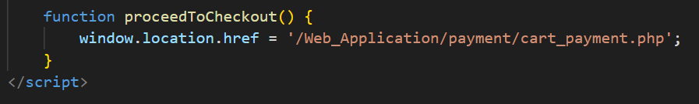

### **2.7.2 Addresse and Payment Details**

At the payment page, the user will have to fill in the essential information like address including unit, state, city and postcode as well as payment method.

# Payment form

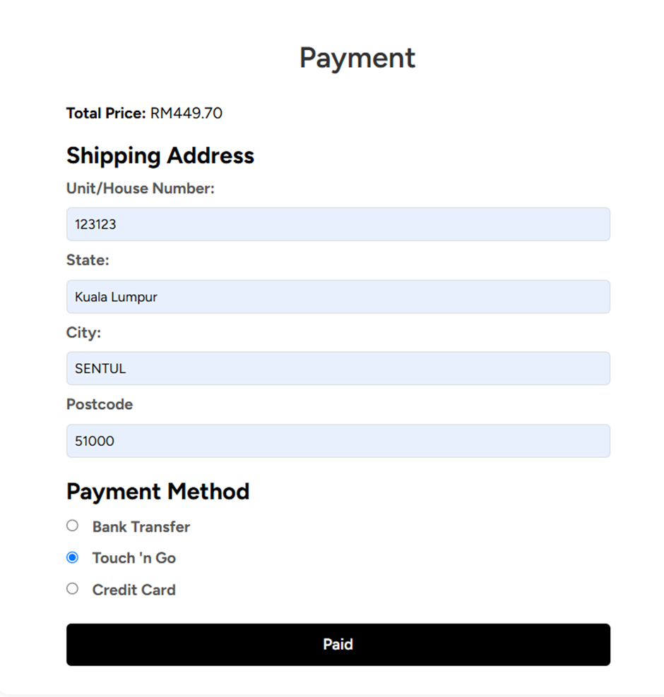

After clicking ‘paid’, they will be directed to the successful payment page if the provided information is satisfied, where the information provided by the user and the product info are retrieved. The stock will be reduced, and the cart will be cleared.

# Form validation in backend

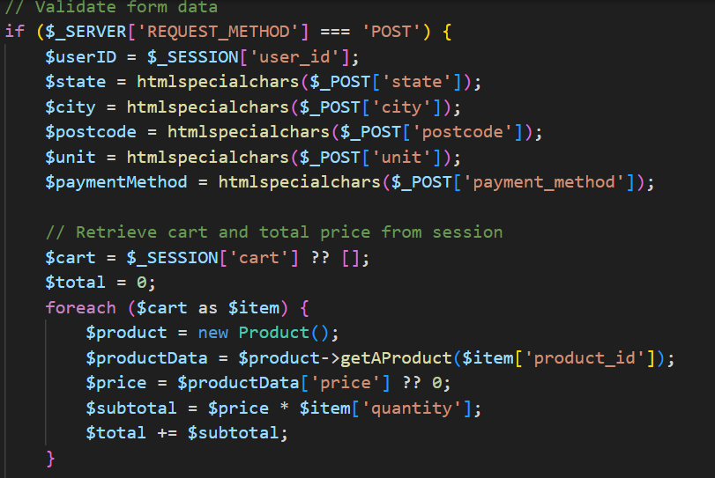

# Form validation using html

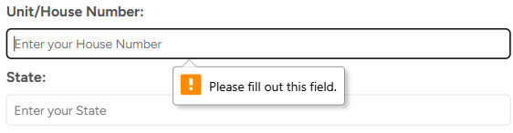

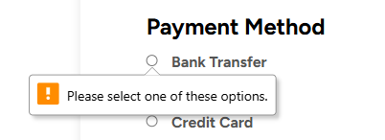

# Message that indicate successfully complete the payment - `success.php`



### **2.7.3 Update stock in database**

# Reduce the stock in database - single product check out

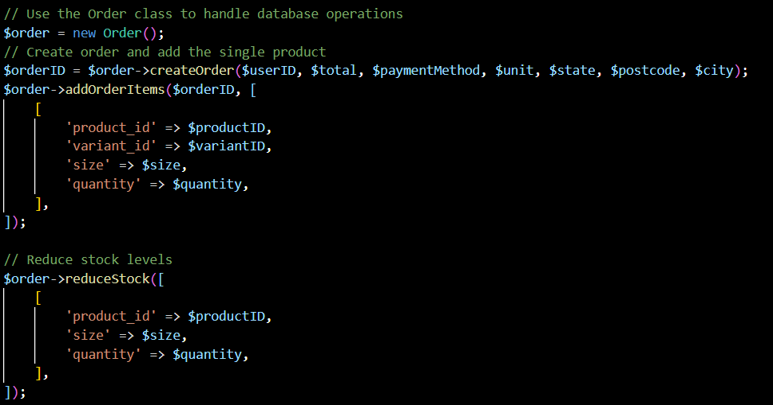

# Reduce the stock in database – multiple products check out

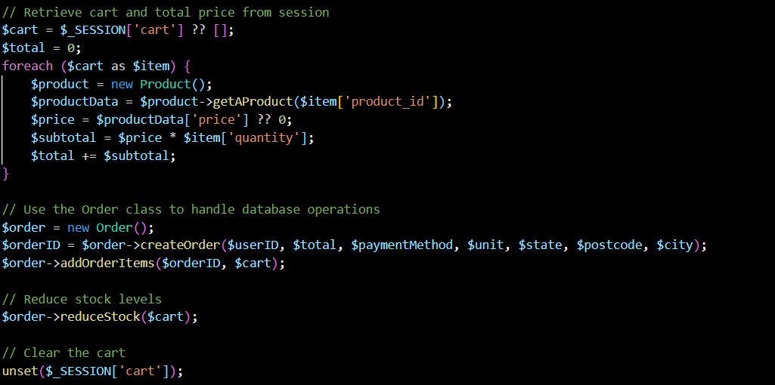

## **2.8 Contact us**

This page provides users with a way to reach out our store for inquiries, support, and feedback. HTML form is used to collect user information and feedback. Besides, client’s side and server’s side validation are applied.

# Contact Info page

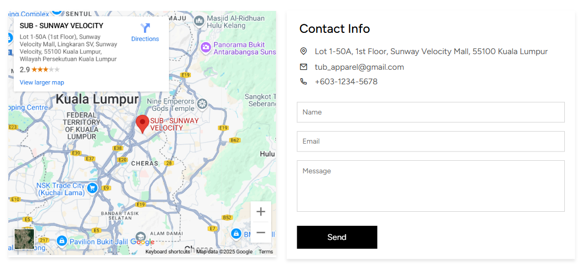

Allows user to key in their personal profile information (etc: Name, Email) and even let them to leave a message to the website and press the send button as response to the website.

# Error message  
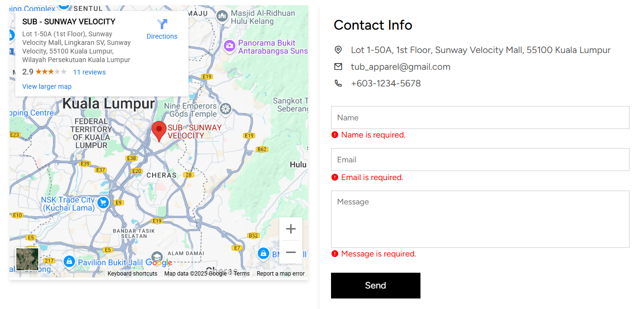

# Client’s side validation – validation.js

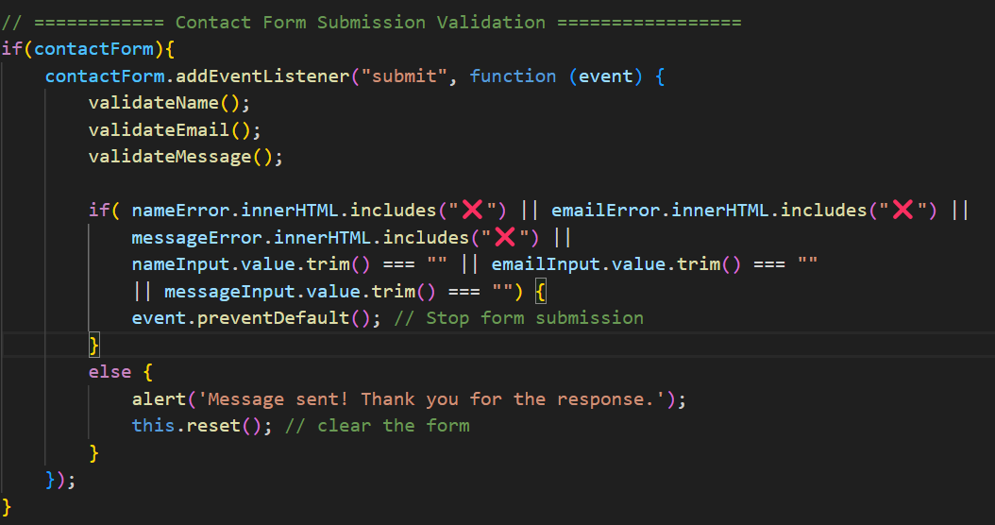

# Function to validate name

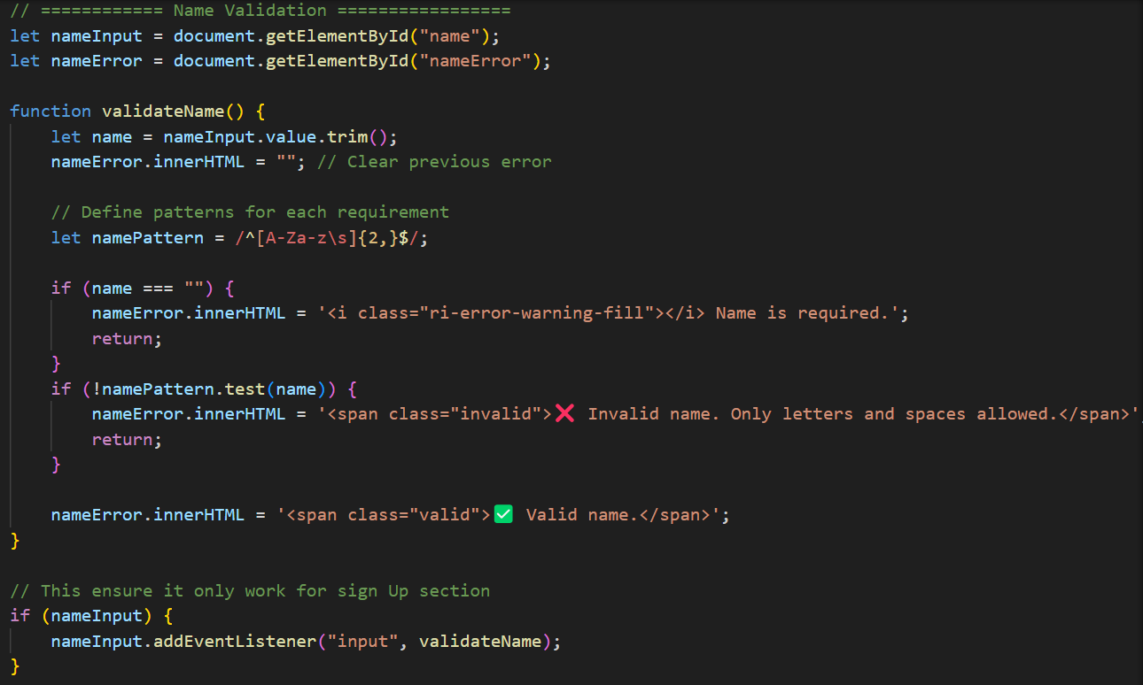

# Function to validate email

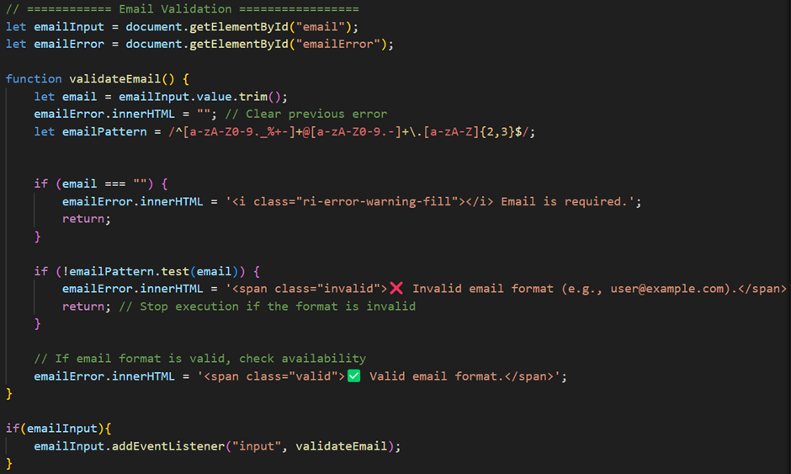

# Function to validate message

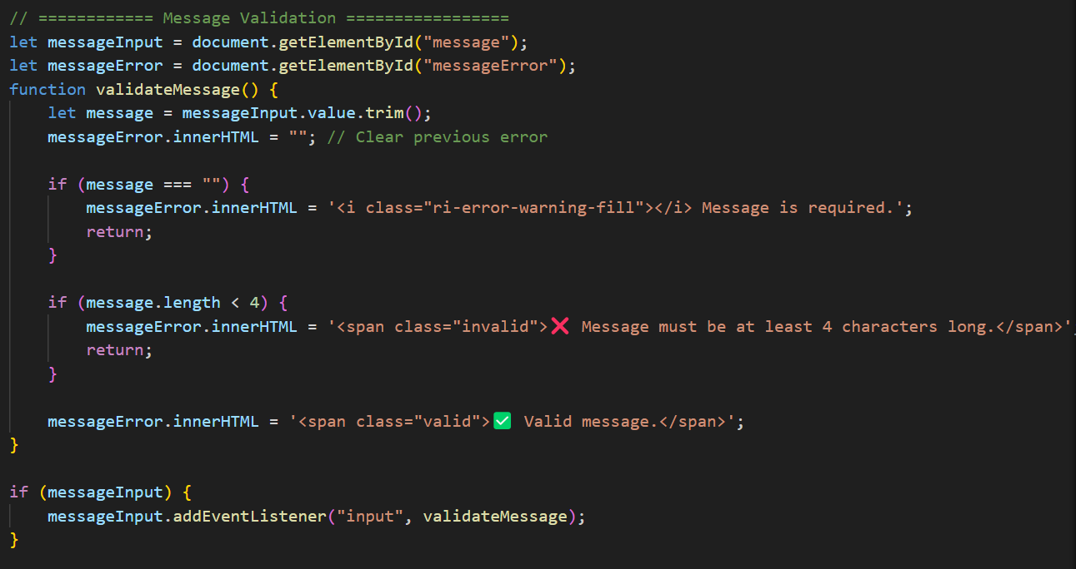

These functions are written in validation.js to allow reusability for other forms that having related input like email in login and registration form.

# Server’s side validation

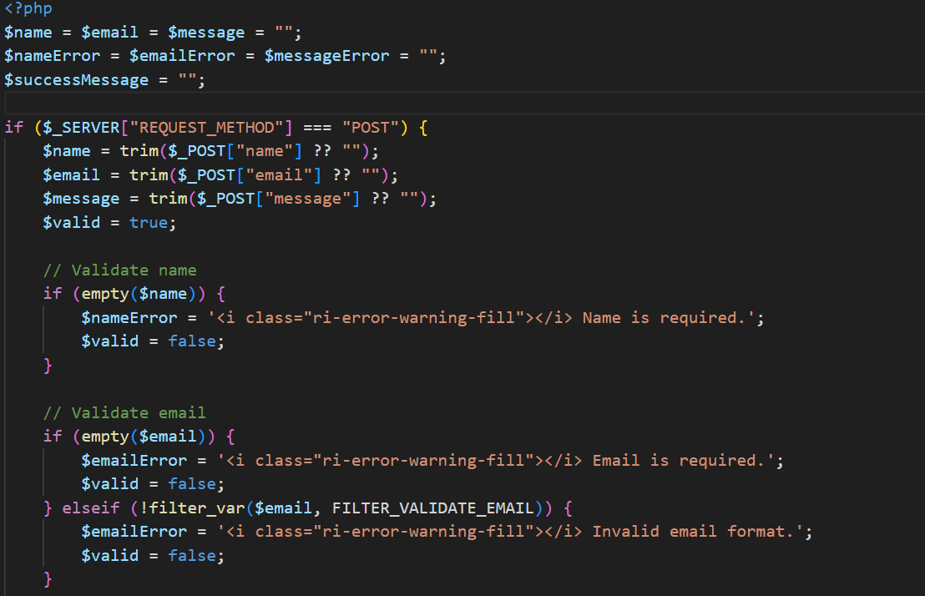

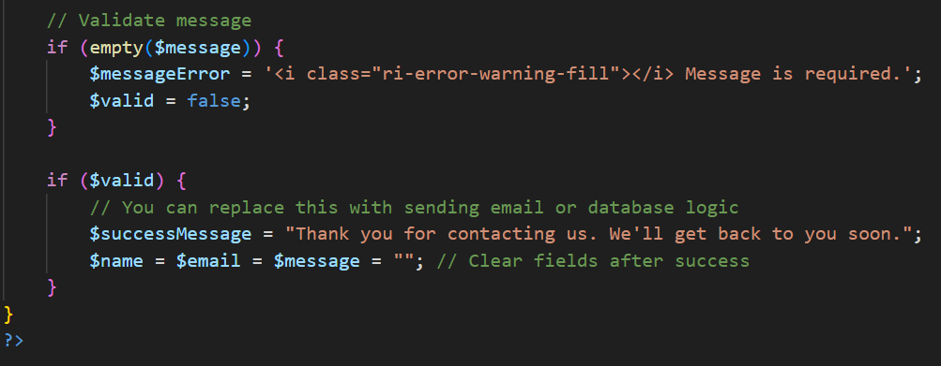

# Error messages will be removed if the condition is satisfied

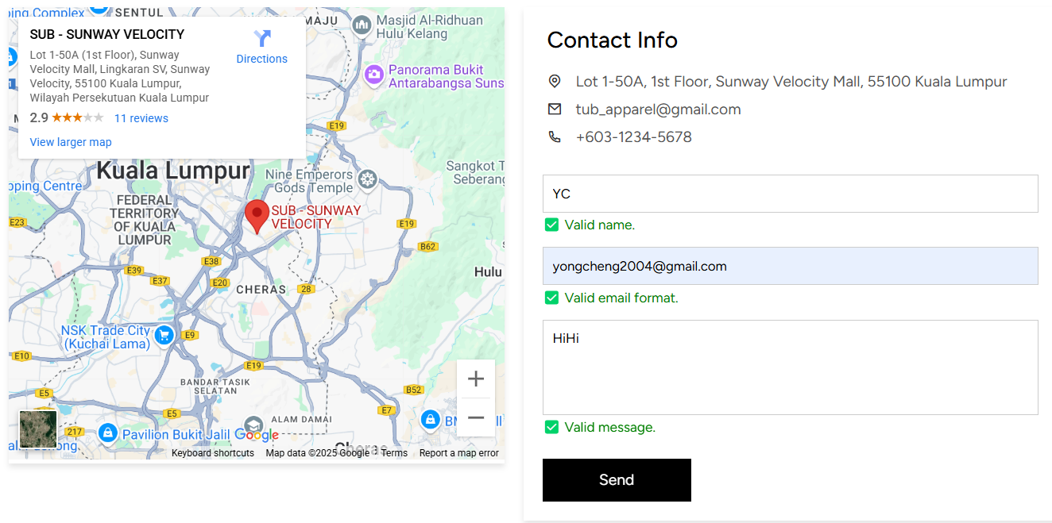

## **2.9 Profile maintenance**

For registered and logged in user, they can view their current information and updated it. At the header, there is a user icon where they can access their profile information. They can also edit their profile, view order history and statistics, or log out.

### **2.9.1 Personal Info**

# User profile page

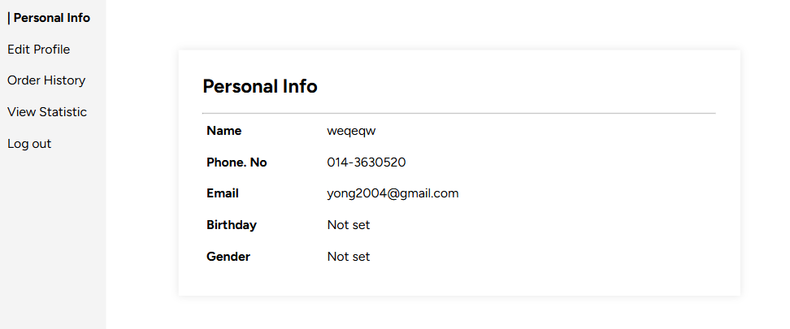

### **2.9.2 Edit Profile**

# User profile page

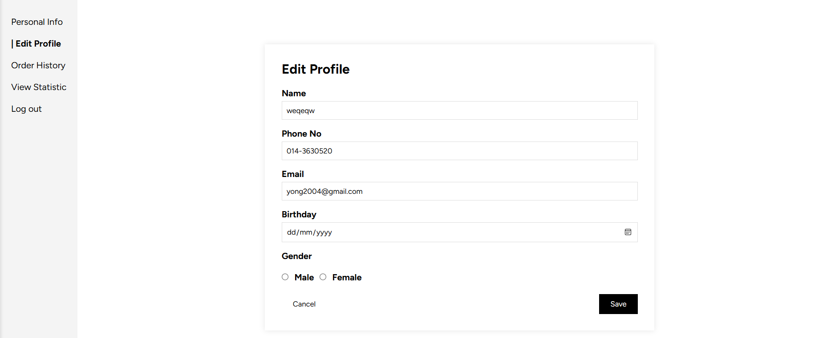

User can edit their profile information, such as name, phone number. Birthday and gender are set as null by default. The user can add them on this page. However, the email addresses are not available for change.

# Error message

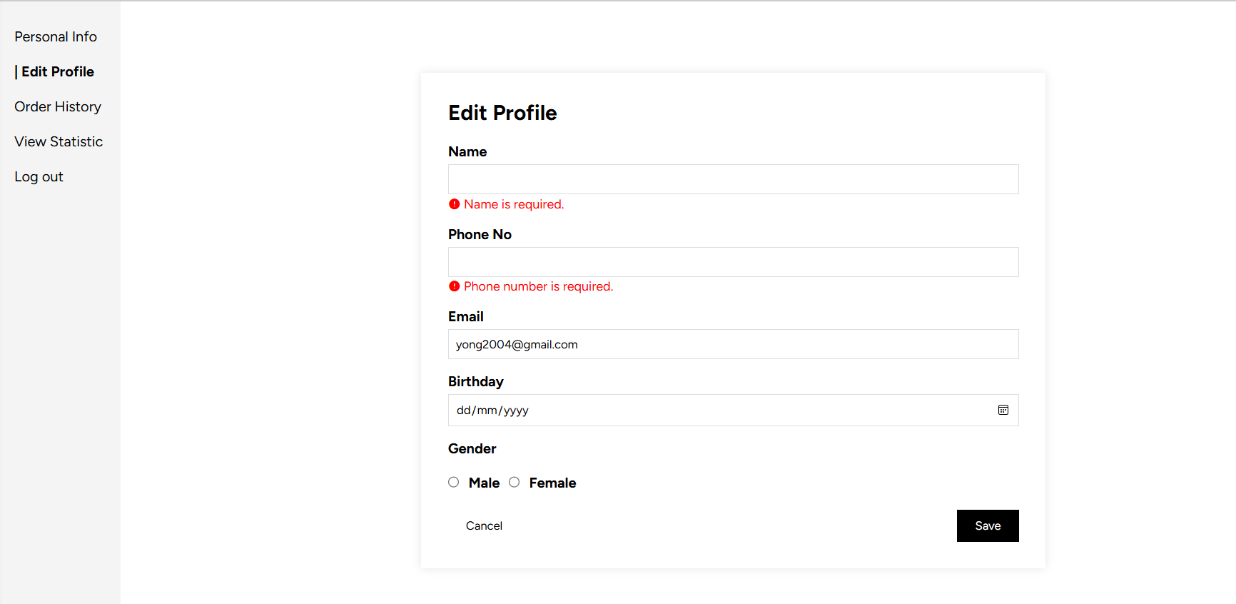

# Client’s side validation – validation.js

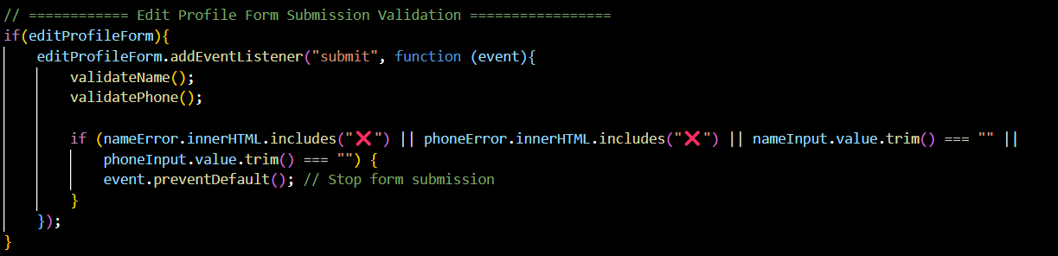

# Function to validate name



# Function to validate phone

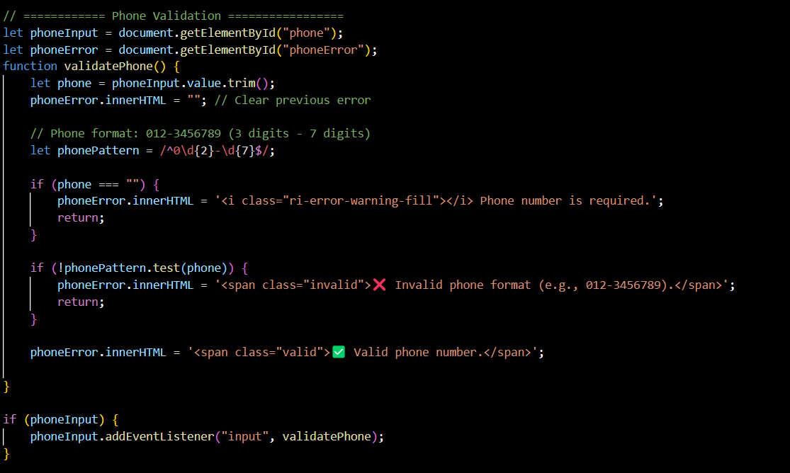

# Error messages will be removed if the condition is satisfied

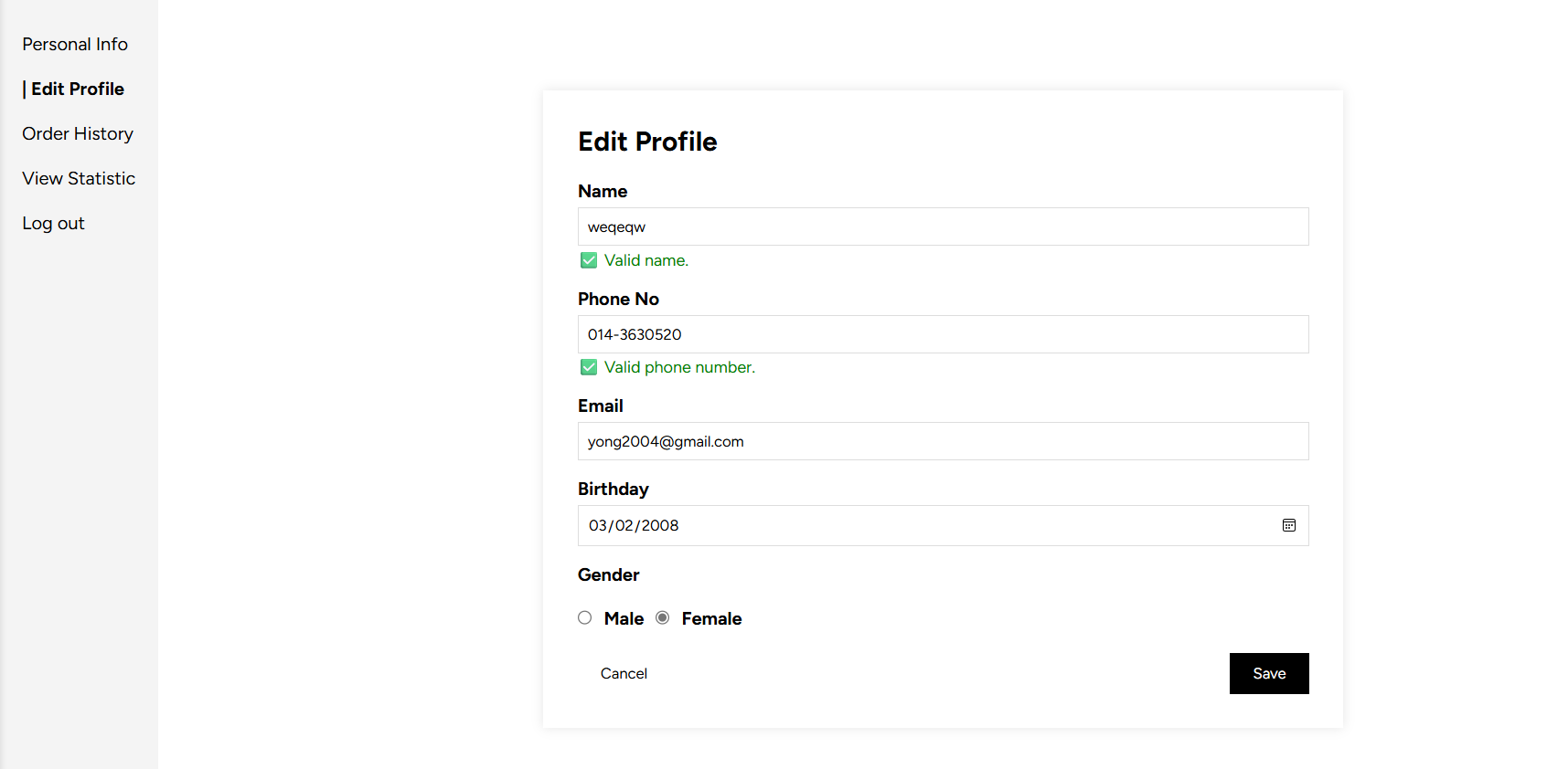

### **2.9.3 Order History**

User can view their past order history here. To view exact details of an order, user can click the underline text in the detail’s column

# Table of order history

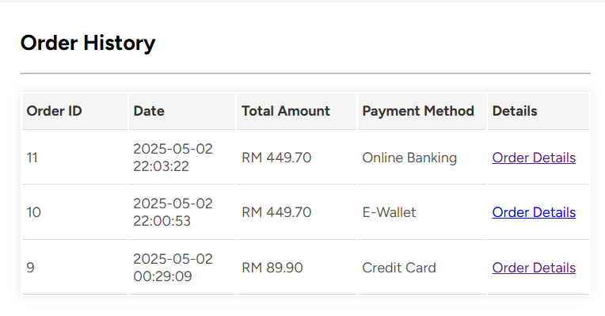

# Order history details

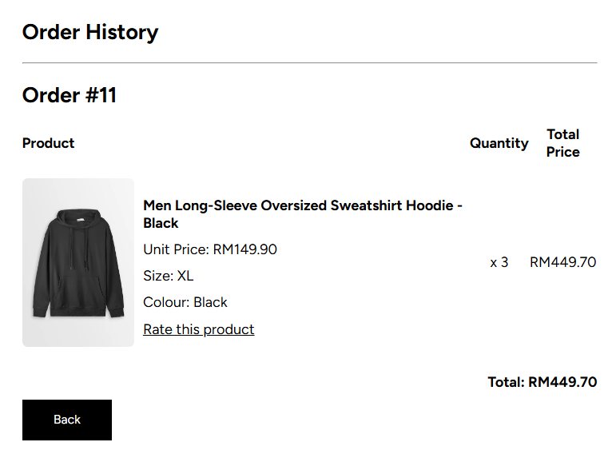

### **2.9.4 Review Product**

For each product purchases, user can give the rating to the product by clicking the “Rate this product” in the order history detail’s page.



# Reviewing product section

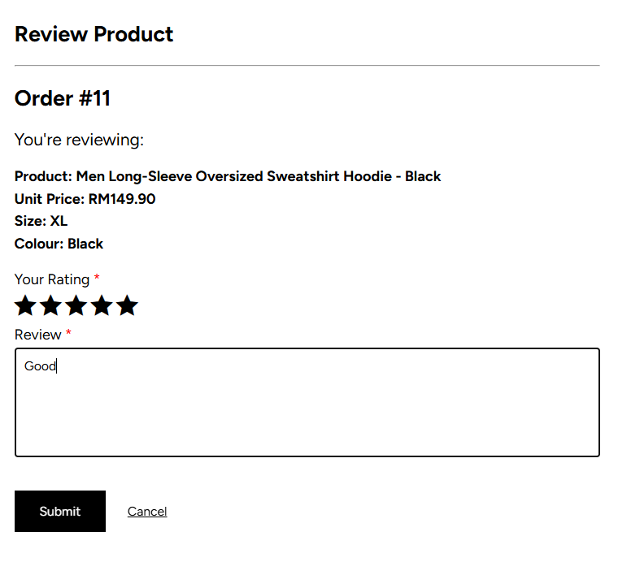

User are required to fill in all the information like rating and review. Same as other form, the client’s side and server’s side validation also implemented. Since the concept are the same, the code snippets are not provided.

# Reviewed product

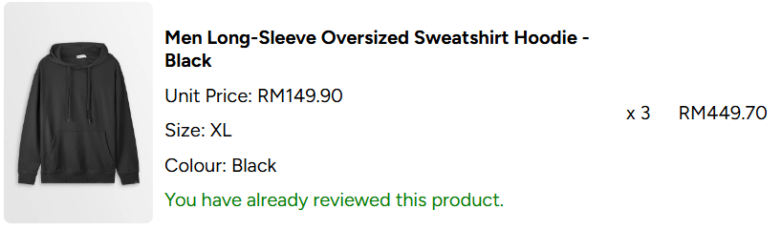

# Latest review in product details section

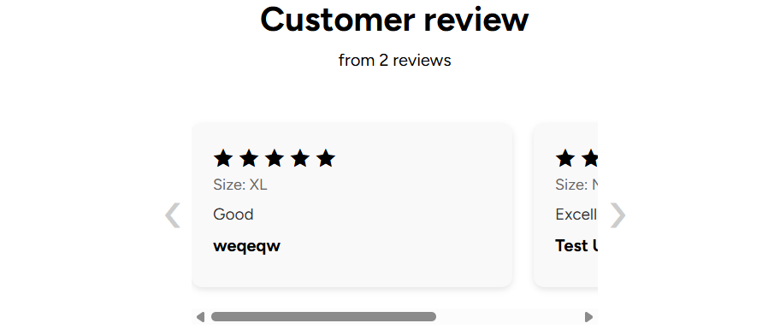

The comments appeared in the product details section and each user can see the comment.

### **2.9.4 View Statistics**

This section allowed user to view the graphical representation of their purchase’s history in yearly. Statistical figures like time series chart, pie chart, bar chart are included as the figure below show. The summarization of statistics is based on the current user only instead of all users.

# Graphical representation of statistics

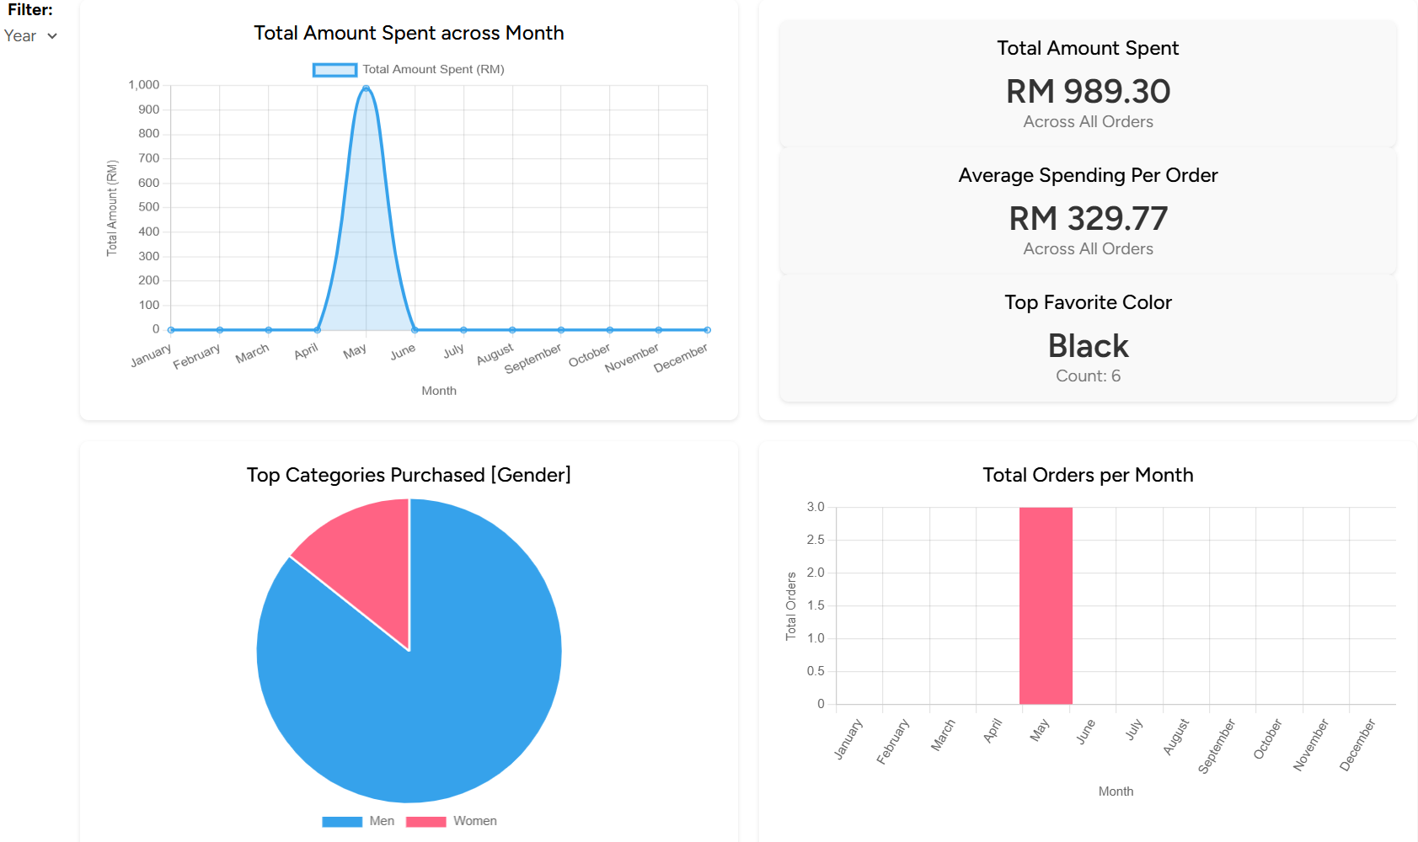

# Year filter

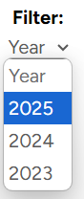

User can also filter the year that wanted to view for the statistics. By default, the statistics result shown is current year.

# Filter for year 2024

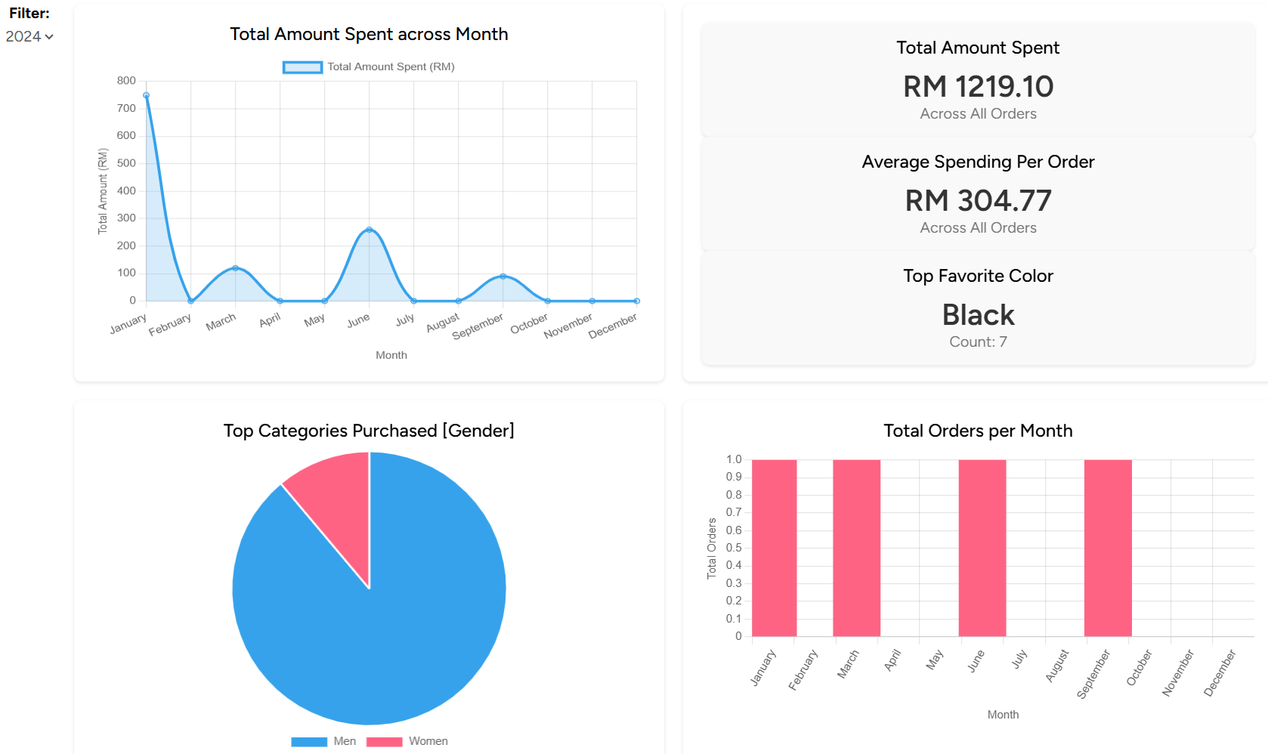

* Reminder: The statistic summarization for the current user is the sample test cases with email: [testuser@example.com](mailto:testuser@example.com) and password: Abcd1234#

## **2.10 Responsive Design**

For this system, we also do the responsive design across different pages. Below are some of the examples.

# Main page

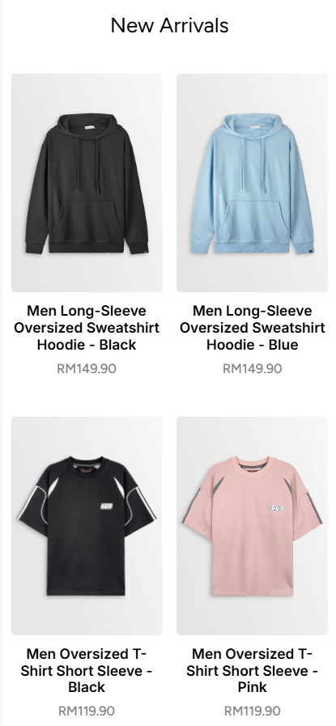

****# Hamburger menu

User can access the navigation menu by clicking the hamburger menu on the top left corner

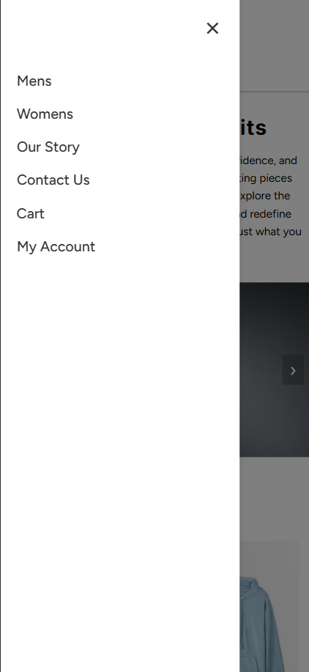# Navigation menu phone viewport

# Product listing page

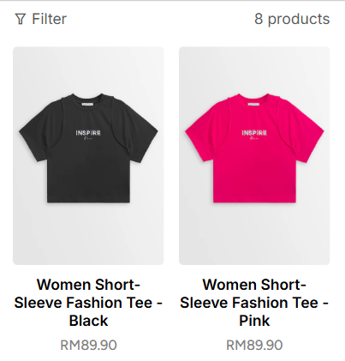

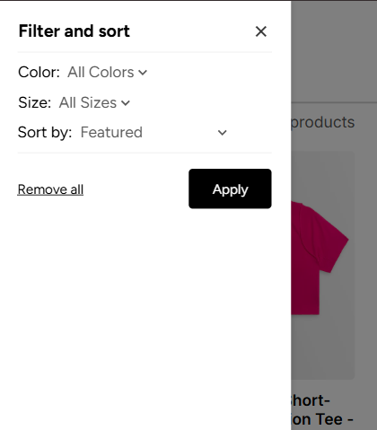User can click the filter icon to select the filter they wanted

**#** Product details page

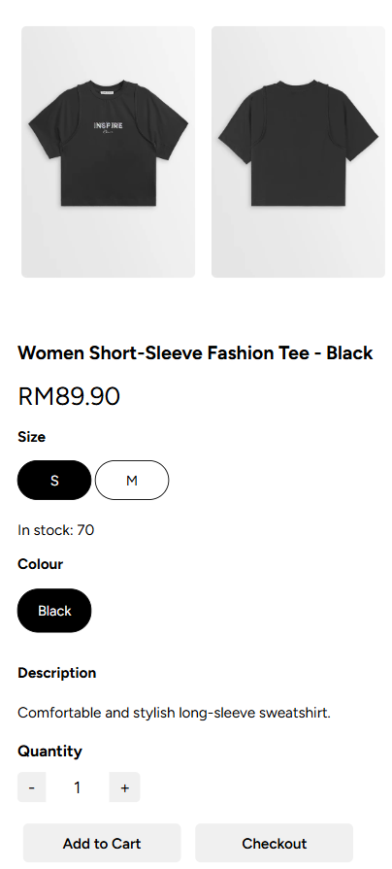

# **3.0 Conclusion**

In conclusion, the development of our apparel and clothing e-commerce website successfully meets the objectives of creating a user-friendly, visually appealing, and functional platform for online shopping. Through careful planning and implementation, we have designed a website that allows users to easily browse, search, and purchase clothing items across various categories. Features such as responsive design, secure payment integration, and user account management were incorporated to enhance the overall user experience and ensure accessibility across devices.

This project not only demonstrates our ability to apply web development skills but also highlights the importance of user interface (UI) and user experience (UX) considerations in building a competitive online store. Moving forward, the website can be further improved by incorporating customer reviews, personalized recommendations, and marketing tools such as promotional banners and newsletters to attract and retain users. Overall, this project provides a strong foundation for launching a modern online apparel store and opens opportunities for future expansion and innovation in the e-commerce space.

# **Extra: Future Enhancement**

For this project, there are still have room for improvement for certain sections. For example, we plan to implement more variety of product into this system and categorizing into different groups like shorts, t-shirts, skirt and so forth. This allows the user to have more choice on our product. Besides, other filters such as ratings, price range would be included in future stage. Apart from that, we planned to build an administrative system which allow admin to perform CRUD on products information like image, stock, size, description and so forth. This can make the system more dynamic and flexible. Lastly, an interactive dashboard for admin also planned to be implemented to analyse user’s behaviour. All these future enhancements would be a big challenge for us! That’s all for this project, thank you Dr Chia for the patience on reading this extra section.

# **4.0 Workload Summary**

|  |  |
| --- | --- |
| **Name** | **Contribution** |
| Goh Yi Cheng | Coded for:   * Home page * Product listing * Product details * Order History Details & Statistical Summary * Review * Report |
| Toh Yong Cheng | Coded for:   * Contact us * Product listing * Product details & Filter * Cart * Responsive * Report |
| Wong Jea Sen | Coded for:   * Login and sign up * Profile maintenance * Check out & Payment * Order History * Report |
| Hiew Yi Zhe | Coded for:   * Privacy policy, FAQ’s * Contact us * Report |

# **5.0 References** SUB. (n.d.). *Home*. <https://www.sub.com.my/>